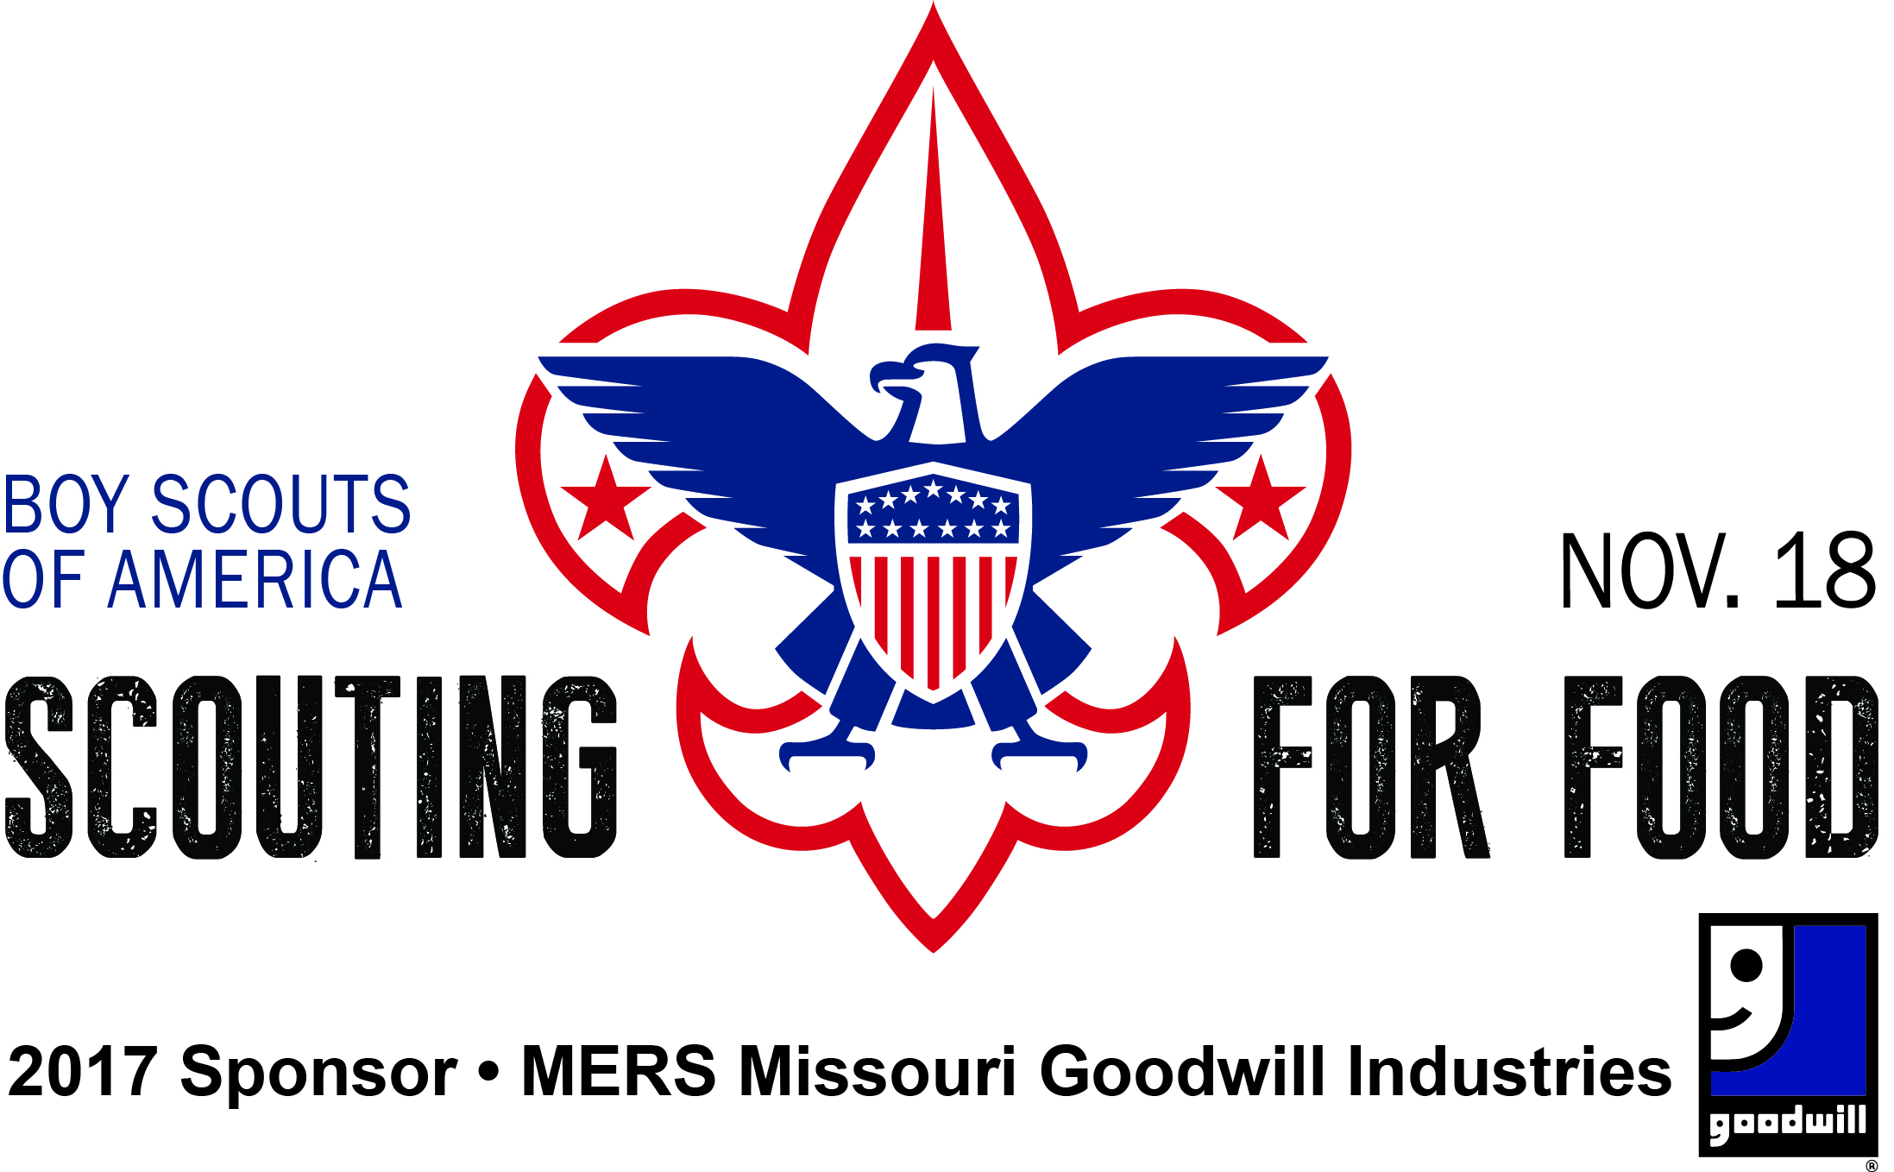

Dear Unit Leader:

Thank you for participating in the Greater St. Louis Area Council’s 32nd Annual Scouting for Food drive. More than 55,000 Scouts in the 51 counties of our council come together for this two-day service project. It is impressive what can be done when we work together. More than 49,000,000 cans of food have been collected during its 32-year history.

Our Good Turn has a positive impact on the community. Food pantries are stocked for the winter months and Scouts have an opportunity to see how community service and volunteerism make a difference. This is truly an outstanding project.

Scouting for Food is as successful as you make it. Be sure everyone knows your plan and expectations. Work your assigned area completely. If you are unable to cover your entire assigned area, contact your District Participation Chairman or District Executive. The public counts on being a part of our Good Turn and people are disappointed when they are overlooked.

To assist you, we have prepared this Unit Information Kit. Please review the materials thoroughly. If you have any questions, contact your District Executive.

Yours in Scouting,

Suzie Redington

Activities Director
Greater St. Louis Area Council, BSA

2017 GOOD TURN

This is the Greater St. Louis Area Council’s 32nd annual Scouting for Food Good Turn, and it continues to be the largest single-day canned food drive in the United States. During its 32-year history, Scouts have collected more than 49 million cans of food.

The 2017 campaign begins on Saturday, November 11. Approximately 55,000 Scouts go door-to-door distributing custom-made plastic grocery bags. On Saturday, November 18, Scouts return to those neighborhoods to collect the bags filled with canned goods. The timing of the campaign coincides with the spirit of giving and appreciation associated with the upcoming Thanksgiving holiday season.

What: An area-wide food drive conducted to support agencies that provide food to those in need. The Greater St. Louis Area Council conducts this drive in 51 counties in southeast Missouri and southeast Illinois. More than 55,000 Scouts and adult Scouters collect food.

When: Saturday, November 11, 2017 – Bag Distribution Day
Saturday, November 18, 2017 – Food Collection Day

How: On a district by district basis, packs, troops, teams, crews and posts are assigned geographic areas in which they distribute bags and, a week later, return to collect bags filled with canned goods.

Units deliver food to a central collection site -- a firehouse or a food pantry. Trucks transport food from firehouses to the St. Louis Area Foodbank for distribution through more than 400 member agencies.

Firehouse Involvement

Participating firehouses in St. Louis City and County provide space for food sorting and boxing on Saturday, November 18. On Saturday, November 18 Sunset Transportation, Inc. will coordinate the efforts of many donated trucks and volunteer drivers to collect all food at the firehouses and transport it to the St. Louis Area Foodbank.

Local Food Pantries

In areas outside St. Louis City and County, units are assigned to take food collected to a local food pantry. Venturers and Explorers assist in shelving food or boxing it for storage.

Partner Agencies

St. Louis Area FoodBank
Fire Chiefs' Association
Sunset Transportation, Inc.
Local food pantries (outside St. Louis City and County)

Greater St. Louis Area Council Boy Scouts of America

2017 SCOUTING FOR FOOD GOOD TURN

UNIT SCOUTING FOR FOOD CHAIRMAN

RESPONSIBILITIES

- Accept responsibility for your unit’s participation in Scouting for Food.

- Actively lead your unit on Saturday, November 11, and on Saturday, November 18th 2017.

- Attend District Briefing Meeting (usually October Roundtable) and secure all needed information and collection supplies. Review the map of the unit’s assigned collection territory and make assignments.

- Be sure that the entire territory is covered. Ensure that Scouts will deliver a bag to all households in assigned territory on Saturday, November 11.

- Arrange for collection of filled bags from households in the same assigned territory on Saturday, November 18, beginning at 10:00 a.m.

Tip: Assign Scouts to collect bags from the same area in which
they delivered them. This will help cut down on missed bags.

Take the food collected to the designated district collection stations (firehouses) in St. Louis City and County and to assigned local food pantries outside St. Louis City and County. This must be done by 4:00 p.m. on Saturday November 18.

PLEASE GO BACK THROUGH YOUR ASSIGNED AREA IN THE EARLY AFTERNOON.
EACH YEAR SOME BAGS ARE MISSED OR ARE SET OUT LATE.

Greater St. Louis Area Council Boy Scouts of America

2017 SCOUTING FOR FOOD GOOD TURN

Unit Game Plan

All units should know their assigned territory. Contact your district executive if you do not know your territory assignment by November 1.

All Scouts and Scouters should be in full uniform. The public will be able to identify us. Thanks to our publicity, they will know why you are there and what it is you are doing.

Select an assembly place and time for November 11 and November 18 -- e.g., unit's regular meeting place or other convenient, central location. Be sure everyone is aware of the time and location.

On November 11

Assemble ahead of time. Brief the adults and Scouts, and distribute the bags.

All Scouts should travel in groups of two or more (the buddy system).

Have enough vehicles to support the number of Scouts and area covered.

Scouts should leave the bags on doors. Do not enter the home. Do not put the bags in mailbox.

Bags should be distributed to residences only, no businesses.

Vehicles should stay as close to Scouts as possible. Adults should be on the streets to supervise.

Remind Scouts and adults the week before Bag Distribution Day and Food Collection Day.

On November 18

DO NOT begin collection before 10:00 a.m. This allows families time to place food outside.

Review plans for the day.

Have your group cover the same area in which they distributed bags. Many homes are missed when Cub Scouts distribute bags, but Boy Scouts collect the food from the same street.

Collection stations are open from 10:00a.m. – 4:00p.m.

At the collection stations, Explorers, Venturers and Scouts will help unload the food.

PLEASE COVER YOUR TERRITORY BY CAR IN THE EARLY AFTERNOON
TO COLLECT BAGS MISSED DURING THE MORNING PICK UP.

Greater St. Louis Area Council Boy Scouts of America

2017 SCOUTING FOR FOOD GOOD TURN

UNIT TERRITORY

1. Your unit should work its assigned territory only. It is crucial that you cover your assigned area thoroughly. Each year the council office receives calls from disappointed people whose homes are missed.

2. On boundary streets, collect on your side of the street only (unless given other instructions).

3. Skip apartment units with controlled access and "No Solicitation" rules. Scouts should not enter a building with multiple units, but with a single entry that would allow a Scout to be out of sight from the street.

4. Collect from private homes only. Do not solicit from grocery stores or other commercial establishments.

5. Be certain Scouts are in full uniform, travel in groups of two or more, and are adequately supervised - this is especially true for Cub Scouts.

6. Collection bags should be distributed door-to-door on Saturday, November 11, beginning at 9:00 a.m. Place bags on a door handle or between a storm door and entry door. Do not put them in mailboxes, which is against the law.

7. Do not tie bags on doors in such a way that people cannot open their doors.

8. Food must be collected on Saturday, November 18, beginning at 10:00 a.m. or later. Collect food from the same area where you distributed bags.

Food should be turned into your district collection station (firehouse) or local food pantry. Collection stations will be open from 10:00 a.m. to 4:00 p.m. and will be supervised by Scouting personnel.

9. If you have any questions, contact your District Scouting for Food Chairman or your District Executive.

HELP PROMOTE SCOUTING FOR FOOD

THROUGH YOUR ORGANIZATION

Dear Leader:

Here are four easy ways to help spread the word about
Scouting for Food through your organization:

- Use the enclosed two-paragraph or four-paragraph
newsletter item, and ask the editor of your school
newspaper or church/synagogue/temple bulletin to
publish it.

- Ask to speak to your school PTA or PTO, or your
congregation about the importance of Scouting
for Food. Enclosed are presentation points that include
all of the necessary information on the Scouting for Food campaign.

- Create Scouting for Food flyers for bulletin
boards throughout your school, church, synagogue,
temple, mosque, or public library.

- Use Facebook or Twitter or other social media platforms to create awareness among your electronic friends.

SCOUTING FOR FOOD

PRESENTATION POINTS

- In our area, it is estimated that 1 out of 10 people will go without food tomorrow. That’s an estimated 420,000 people that will go without food on a regular basis.

- Of that number, it is estimated that 140,000 are children that will go to bed hungry.

- Scouting for Food, which was started in 1985 by the Greater St. Louis Area Council of the Boy Scouts of America, has since grown into the nation’s most successful single-day food drive.

- Last year, the Boy Scouts collected 2.3 million cans of food for area food pantries. The food drive has collected more than 49 million cans of food since its inception.

- This year Boy Scouts will distribute Scouting for Food bags throughout neighborhoods in the Greater St. Louis Area Council on Saturday, November 11, 2017.

- They will return the following Saturday, November 18, to collect the filled bags.

- Any canned food item you can donate would be greatly appreciated.

SCOUTING FOR FOOD NEWSLETTER ITEM #1

(Cub pack, Scout troop, Varsity team, Venturing crew, Explorer post # ) sponsored by (________________________________________________________) needs your help - and so do thousands of hungry people in our community.

Our Scouts are participating in the annual Scouting for Food drive this fall. The 2017 food drive will take place on two consecutive Saturdays. On November 11, Scouts will place plastic bags at doorsteps throughout St. Louis City, St. Louis County, the surrounding counties, southeast Missouri, and southern Illinois. The following Saturday, November 18, Scouts will return to pick up the filled bags. Food donated in a particular area will be distributed through relief pantries in that area.

SCOUTING FOR FOOD NEWSLETTER ITEM #2

(Cub pack, Scout troop, Varsity team, Venturing crew, Explorer post # ) sponsored by (________________________________________________________) needs your help - and so do thousands of hungry people in our community.

Our Scouts are participating in the annual Scouting for Food drive this fall. The 2017 food drive will take place on two consecutive Saturdays. On Saturday, November 11, Scouts will place plastic bags at doorsteps throughout St. Louis City, St. Louis County, the surrounding counties, southeast Missouri, and southern Illinois. The following Saturday, November 18, Scouts will return to pick up the filled bags. Food donated in a particular area will be distributed through relief pantries in that area.

This year the Scouts hope to match or better the success of last year’s food drive - which resulted in 2.3 million cans of food collected. This year the food pantries are looking for protein food such as canned tuna, peanut butter, or canned ravioli.

Your help is desperately needed. Please be sure to look for your Scouting for Food bag on November 11 and fill it with any canned food items you can donate. Scouts will collect the donations from your doorstep on November 18.

