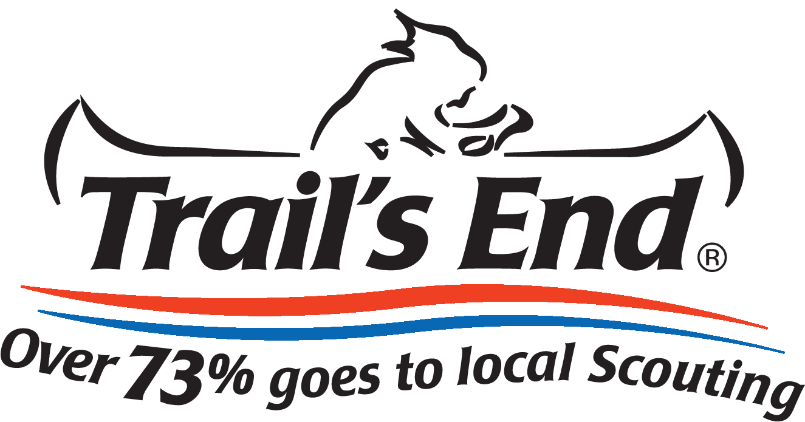

Trail’s End Popcorn Sales System Manual
Reference Guide for Unit Leaders

Scouting.Trails-End.com

Introduction
The Popcorn Sales System makes it easy for you to manage your Trail’s End Popcorn Sale using a convenient, web-based platform. Using this platform, you can:
- Order popcorn from your Council to sell and earn needed funds for your Unit
- Add Popcorn System Users to help organize your information
- Create and manage Scout lists and sales records
- Track your Unit’s online sales, print packing slips and invoices
Your Council will setup your initial account and permissions in the Popcorn System. Users with administrative access (Leaders) will be able to change data in the system (add, edit or delete). Read-only users (Members) can mostly view data in the system, and manage their own personal account information. The menus and pages you see when you are logged into the Popcorn System are determined by your role and your organizational responsibility.

Your Role – Some menus and other features are available only to Leaders. If you are a read-only user (member), these menus and features will not appear when you log into the Popcorn System. If you are the Popcorn Kernel of more than one unit, you may have multiple roles available to use.

If you have any questions, reach out to your Trail’s End Sales Manager or send us an email at help@trails-end.com.
Table of Contents
Introduction…………………………………………………………………………………..2
Table of Contents……………………………………………………………………………3
Unit Checklist………..………………………………………………………………….…4-5
Logging In………………………………………………………………………………….6-7
Unit Homepage………………………….…………….…………………………….…..8-11
- Select a Sales Cycle……………………………………………………………9-10
- Select a Role……………………………………………………………………10-11
Manage Your Profile…………………………………………………………………...12-13
Users – Creating, Editing, Viewing and Deleting……………………………………14-17
Unit Scout List………………………………………………………………………………18
Unit Popcorn Ordering…………………………………………………………………19-25
- Placing a Unit Order – Show-N-Sell…………………………………………..19-20
- Placing a Unit Order – Take Order…………………………………………...21-25
  - Entering Scout Orders
Tracking Scout Sales…………………………………………………………………..26-29
Online Selling……………………………………………………………………………….30
Unit Checklist
Use the Checklist below as a guide for administrating your Unit’s Popcorn Sale.

- Create Unit Users
(Contacts Menus)
  - Add any additional unit users anytime.

- Build your Scout List
(Scouts Menu)
  - Add your Scouts to enter Scout Take Orders and track their sales for prizes

- View your Unit’s Commission
(Commissions Menu)
  - View your unit’s popcorn sale commission structure
  - If enabled, select between the prize program or the cash only option

- Place the Unit Popcorn Order
(Unit Order Menu)
  - Enter Scout orders (Scout Tracking menu – Take Order Only)
  - Enter and Submit unit order for Council to approve

- Place the Unit Prize Order
(Side Navigation)
  - Record Scouts’ Show-N-Sell amounts in the Scout Tracking page
  - Click the Prize Order button
    - Option only available if Council uses a prize program
  - Place your Unit Prize Order
All unit orders flow through your Council
- Scout Orders System reflects Scout need in your unit order
- Unit Orders System reflects unit’s need in Council order
- Council Order Submitted to Trail’s End for delivery

- Reports
(Side Navigation)
  - Print Packing Slips for unit and for Scouts
  - Print Invoices for popcorn orders

Logging In
- Go to Scouting.Trails-End.com in your internet browser (Firefox and Chrome are preferred).

- Type your Username and Password into the respective fields (if you do not have an account, please contact a Council admin user in your organization or your Trail’s End Sales Manager).

- Click the Sign In button

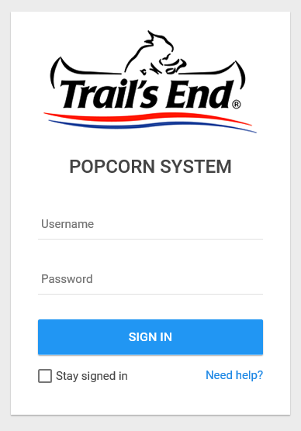

- If you have forgotten your Username or Password, click the Need Help? link and follow the prompts to have your Username or Password emailed to your email address on record.

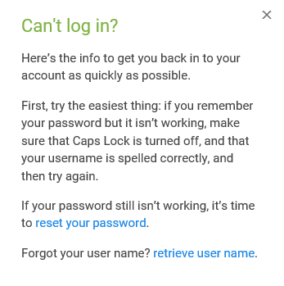

Unit Homepage
Your unit homepage has everything you need to setup your unit’s sale. The links in the top navigation are in order from left to right to easily guide you through the process of getting ready to order Trail’s End Popcorn.
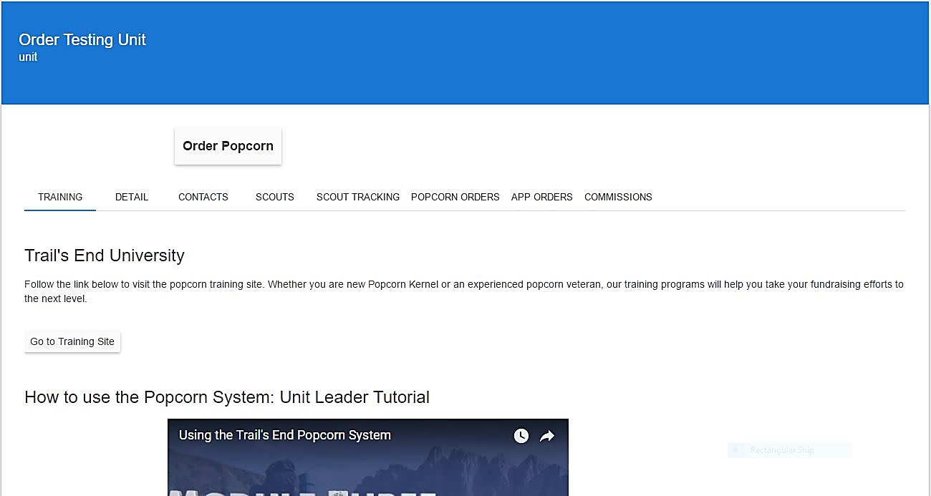
The sidebar navigation will continue to be populated with quick, helpful links and will become more robust over time.
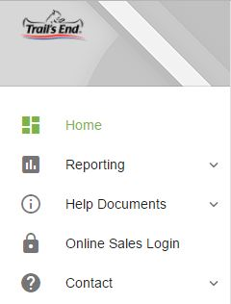

Select a Sales Cycle
- Upon logging in, double check to make sure that the available period is set to the current year (first dropdown box). The system is set to automatically default to the current fundraising sales cycle and campaign.
- If you would like to look at previous years’ information, you can change the fundraising sales cycle and campaign by clicking on the dropdown box.
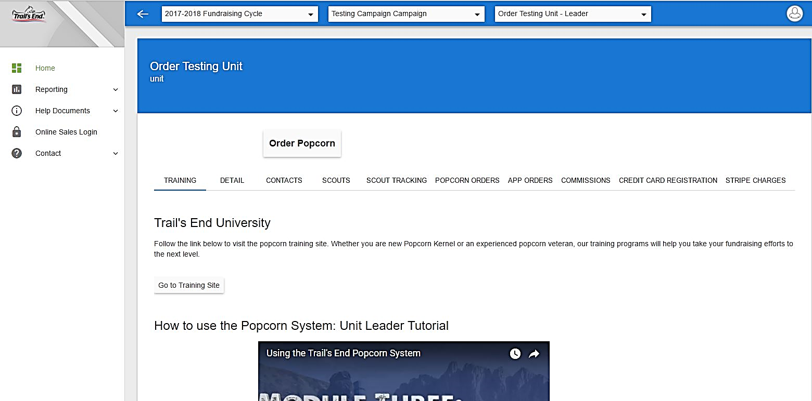
Select a Role
- Depending on your access in the system, you may be assigned to one or many roles (i.e. Unit leaders can order popcorn for more than one unit). To switch between roles, click on the third dropdown box to switch between your unit accounts.
- Select the role in which you want to work. The role can be switched at any time during your session.

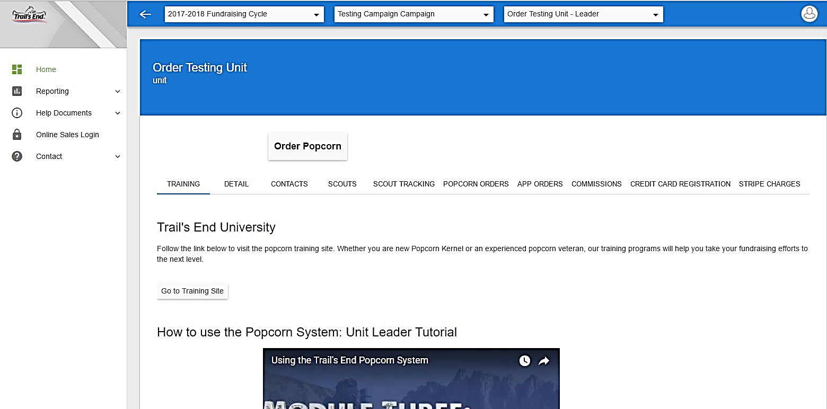

Manage Your Profile
View Your Account Profile
- In the top right corner, click the white circle to display a drop-down list of options.
- Click the My Profile link to view your account details and your role(s) within the system.
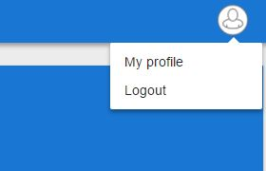
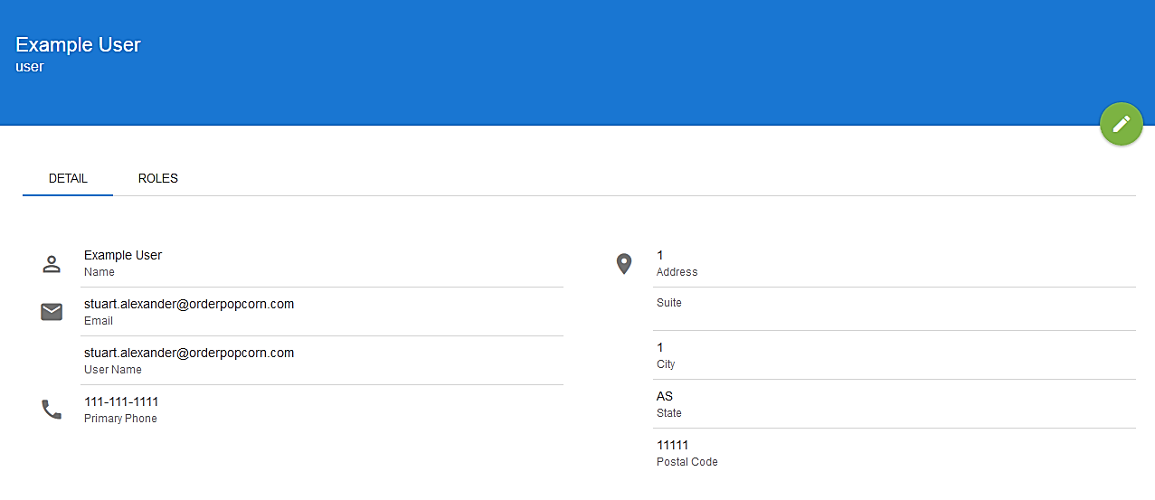

Edit Your Profile
- Once in your My Profile, click Edit button (green circle with pencil)
- Make any necessary changes to your account details, including updating your password, by changing the text in the editable fields, and click the Save button (green circle with checkmark)
- To leave with page without saving changes, click the Cancel button (red circle with X)
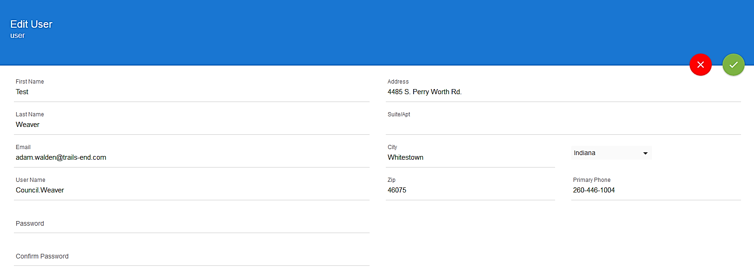

Users – Creating, Editing, Viewing and Deleting from Unit
Create a Unit User
- From the unit homepage, click the Contacts tab.
- Once on the Contacts tab, click the New User link in the top left corner of the contact list.
- Complete the New User form, and click the Green Checkmark button to create a new user, or click the Red X button to go back without saving.
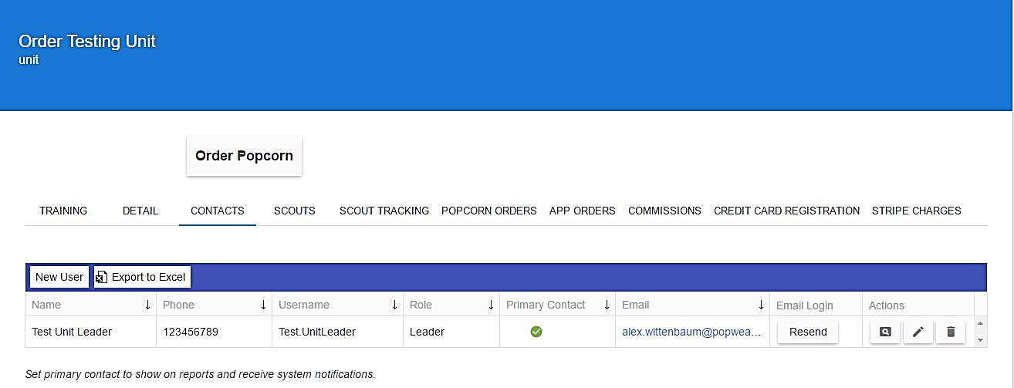

Edit a Unit User
- From the unit homepage, click the Contacts tab.
- Once on the Contacts tab, click the Edit button (square pencil symbol) next to the unit user you wish to edit.
- An editable form will appear with the details of the unit User. Make edits as needed and click the Green Checkmark to save your changes, or click the Red X button to go back without saving.
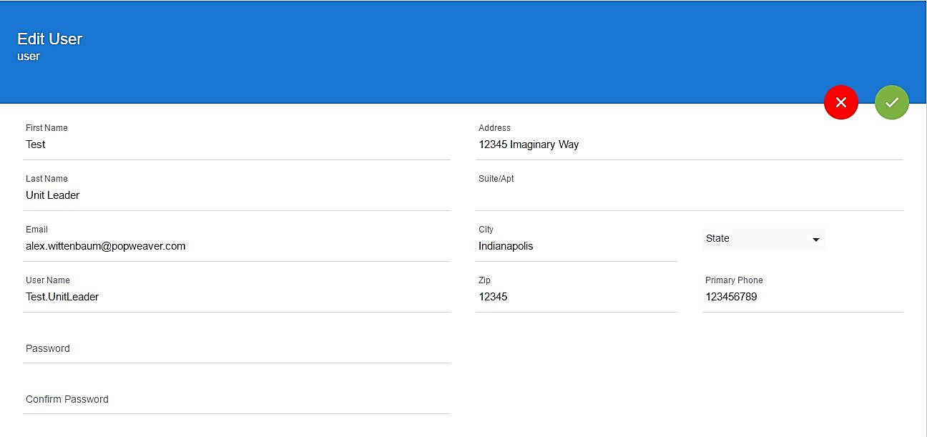

View a Unit User
- From the Unit homepage, click the Contacts tab.
- Once on the Contacts tab, click the View button (magnifying glass symbol) next to the unit user you wish to view.
- The details page of the unit User will appear to view the user’s information and their assigned roles.
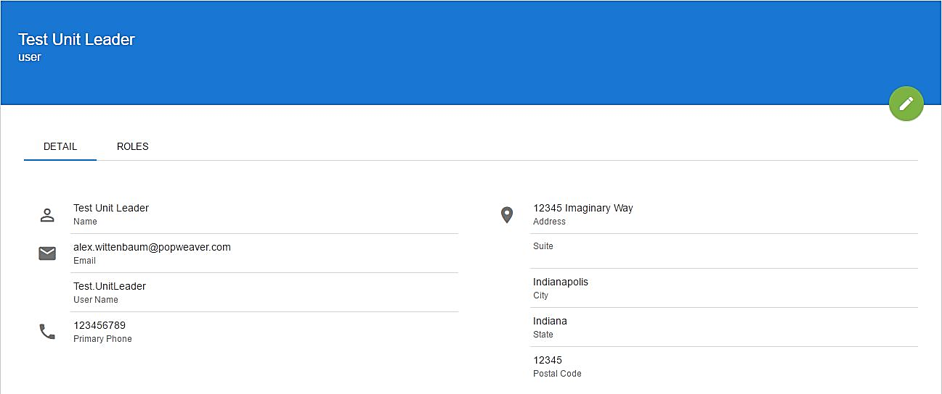

Delete a Unit User
- From the unit homepage, click the Contacts tab.
- Once on the Contacts tab, click the Delete button (trashcan symbol) next to the unit user you wish to delete.
- A pop-up will appear asking to confirm your decision to delete, or to cancel the action.
*Please note that deleting a user cannot be undone.
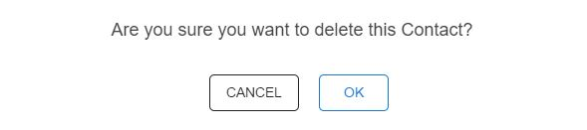

Unit Scout List
The Popcorn System allows unit leaders to track the popcorn sale for each Scout. To view your unit’s Scout list, click the Scouts tab on your unit homepage. The Scout list is populated in two ways: manually by a unit leader and by Scouts registering Trail’s End online selling accounts at www.Trails-End.com. Scouts that have registered online selling accounts, and affiliated their accounts to your unit should already be displayed in your Scout list.
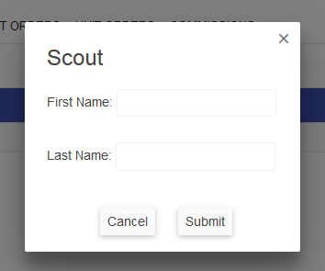
Managing Scout List
- From the unit homepage, click the Scouts tab.
- Click the New Scout button.
- Type the first and last name of the Scout, and then click Submit.
- Click the pencil button to edit a Scout, and the trashcan button to delete.
- Click the move button to move scouts to another unit in the council.
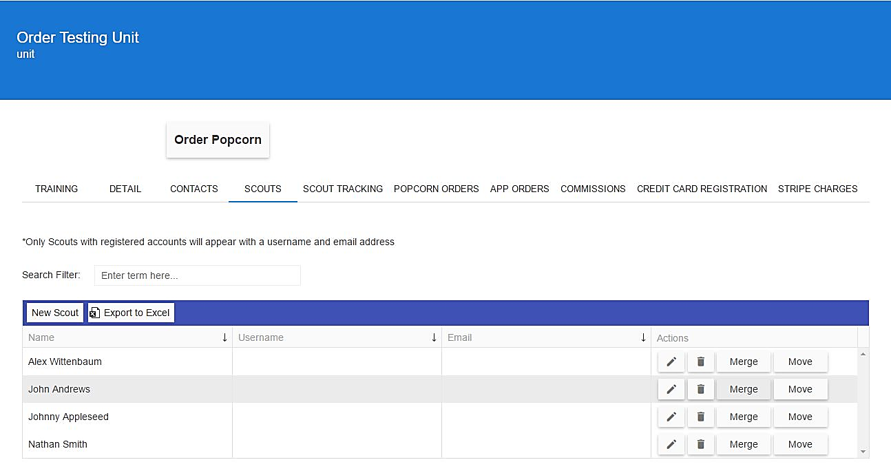
- Click the merge button to bring duplicate scout accounts together.
Unit Popcorn Ordering
When Councils are creating forecasted orders, there are two main settings that determine how a unit can order: Scout Orders and Case vs. Container Ordering. At the beginning of the season, many units pre-order popcorn for store front sales (Show-N-Sell), therefore, Scout Orders are not required for placing the Unit Order. The last order of the season, typically referred to as the Take Order, it is common that leaders will be required to enter Scout Orders (entering the quantity sold by each Scout on their Take Order Forms) before placing the unit order.

A case of Trail’s End product contains multiple selling units, whereas a container is equivalent to one selling unit of product (bag, carton, collection box, tin, etc.). Some orders may require your unit to order only by the case (CS), and some may allow you to order down to the container (CT).
Placing a Unit Order – Show-N-Sell
- From the unit homepage, click the Order Popcorn button. This will take you to the New Unit Order screen
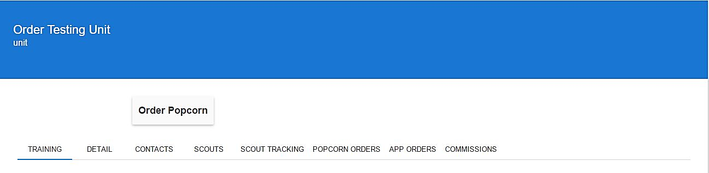
- From the dropdown menus, double check to make sure that the correct campaign is set (This automatically defaults to the current year) and select the appropriate order from the “Choose Delivery” dropdown box to populate the product ordering rows.
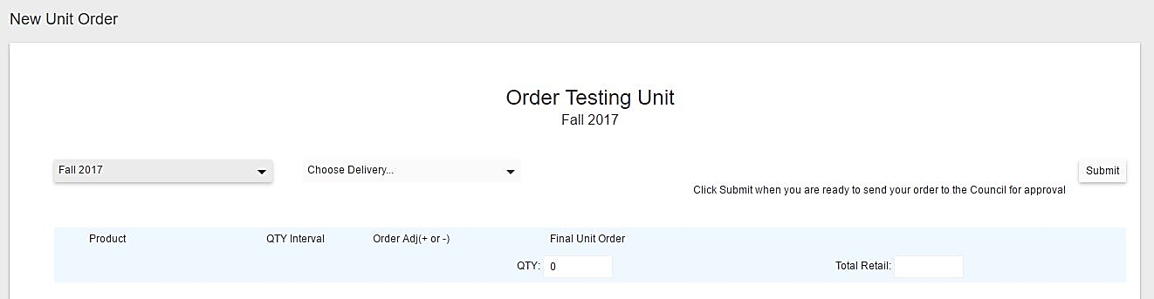
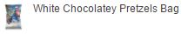
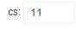
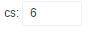
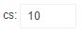
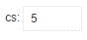
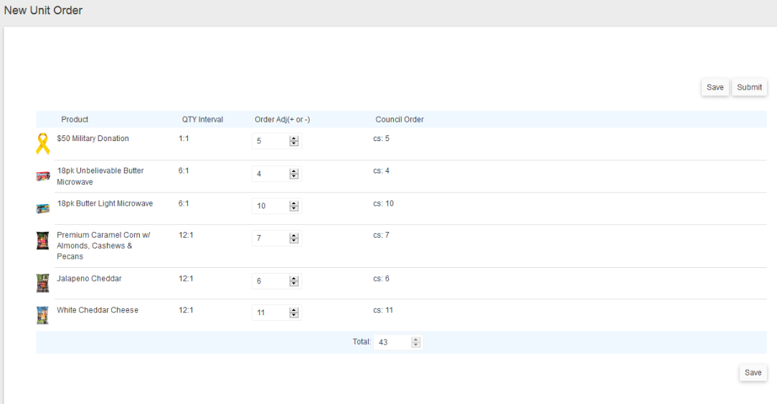
- Use the Order Adj column to enter and/or adjust the order quantities (use positive or negative integers to adjust), and then click Submit to send your order to your Council for approval, or click Save to hold your quantities to be submitted at a later time. The Council Order column will reflect your final order quantity to your Council.

Placing a Unit Order – Take Order (Scout Orders Required)
- Click the Scout Tracking button.
- On the Scout Tracking page, double check to make sure that the current campaign is set (This automatically defaults to the current year).
- If your Council requires Scout orders, the order column will have a hyperlink called Enter Order. Click Enter Order next to each Scout to begin placing Scout Orders.
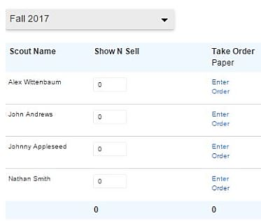
- Double check to make sure that the current campaign is set (This automatically defaults to the current year) and select the correct order from the Choose Delivery dropdown menu to populate the Scout ordering screen.
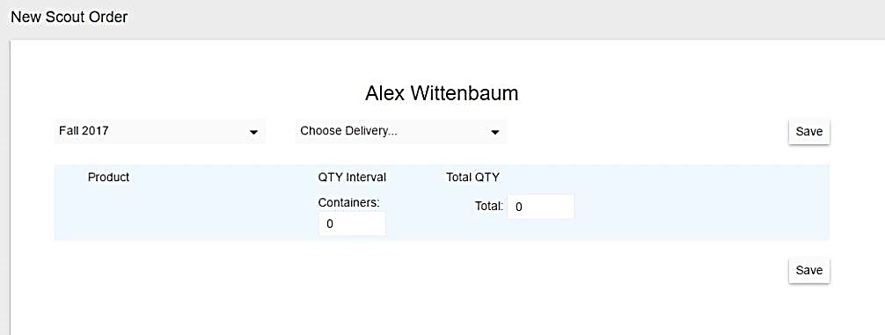
- Enter the quantity sold in containers of each product by the Scout, and then click the Save button. The quantities entered for all Scouts will aggregate in your unit popcorn order in the Total Need column.

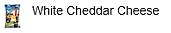
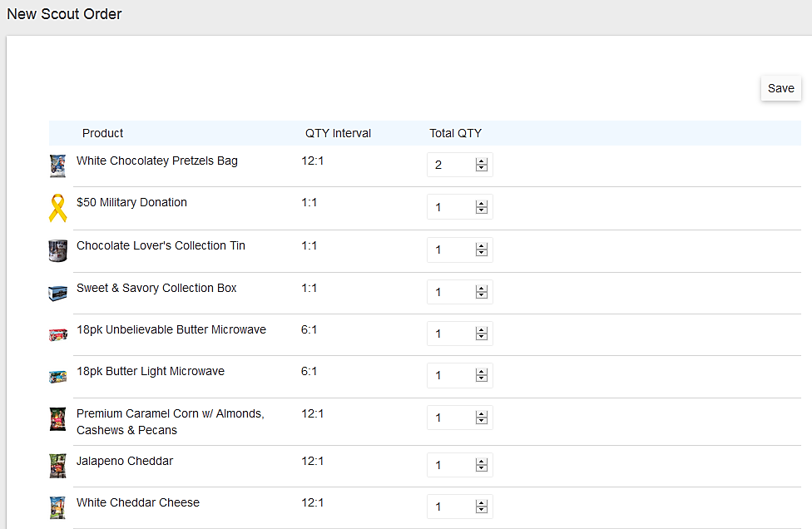
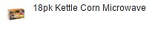
- Once you have entered Scout Orders for all of your Scouts, click the Order Popcorn button.
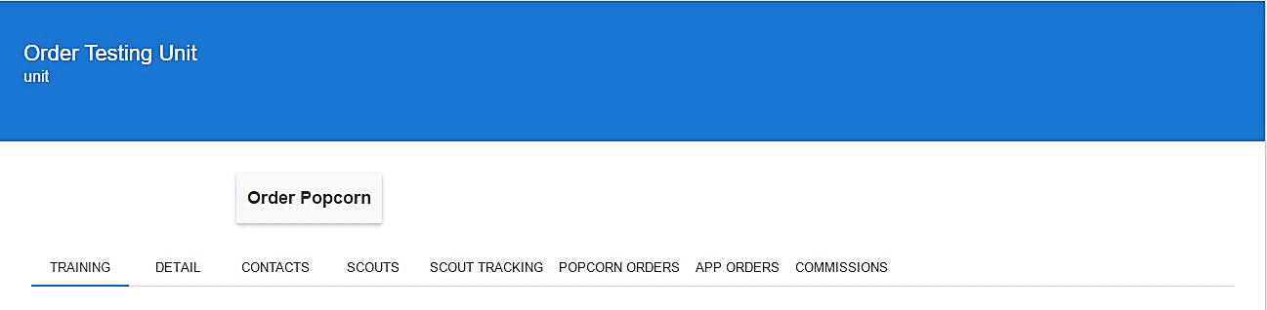
- From the dropdown menus, double check to make sure that the current campaign is set (This automatically defaults to the current year) and select the appropriate order to populate the product ordering rows.
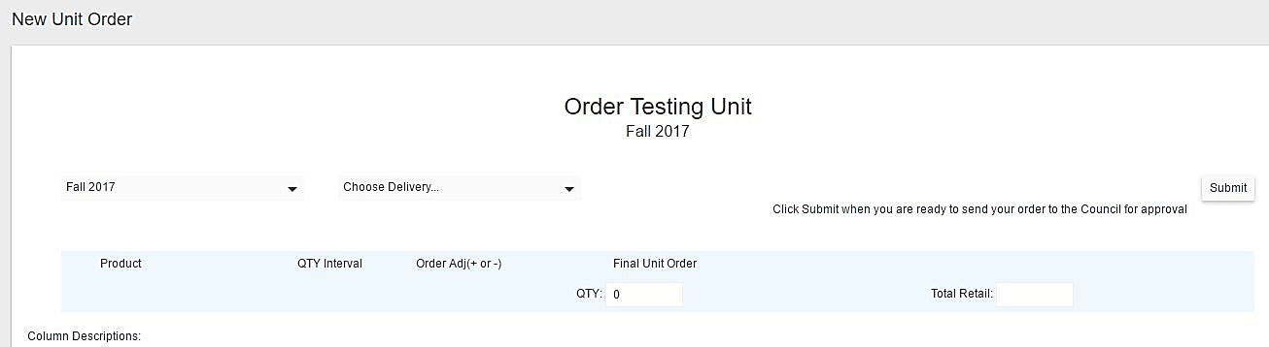
- Once the product rows populate, you are ready to enter your unit Take Order. The Total Need column is the aggregate of all of your Scout Orders. Use the Order Adj to enter/adjust the unit order to the Council (CS = Case, CT = Container). The Council Order column reflects the final quantity of the order submitted to your Council, and the Surplus/Shortage column shows if your order to the Council is more or less than the Scout need.
*You may have inventory leftover from a previous order. If you plan to use leftover inventory to fulfill your Scouts Orders, negatively adjust the order quantity so that you do not over order.
- Click Submit to send your order to your Council for approval, or click Save to save the quantities in your order to be submitted at a later time.
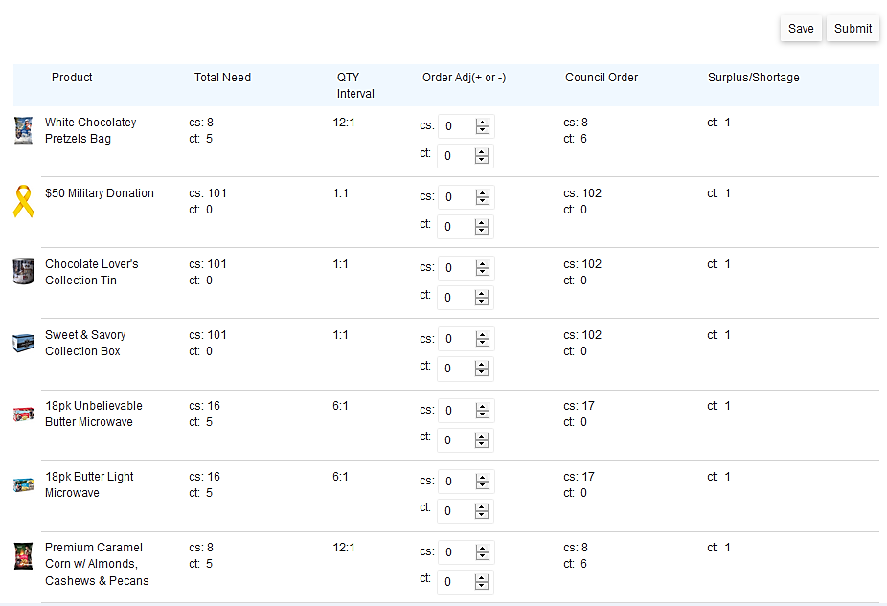
- To return to a saved unit order, or to check on your order’s approval status, click the Popcorn Orders tab.
- Double check to make sure that the current campaign is set (This automatically defaults to the current year).

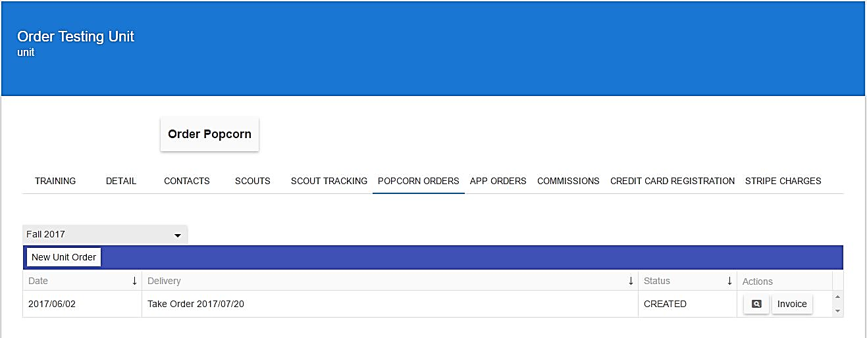
- Click the magnifying glass to go back to the order you wish to edit and submit.
- Click the Invoice button to view your popcorn invoice (only orders in APPROVED status will generate an invoice).
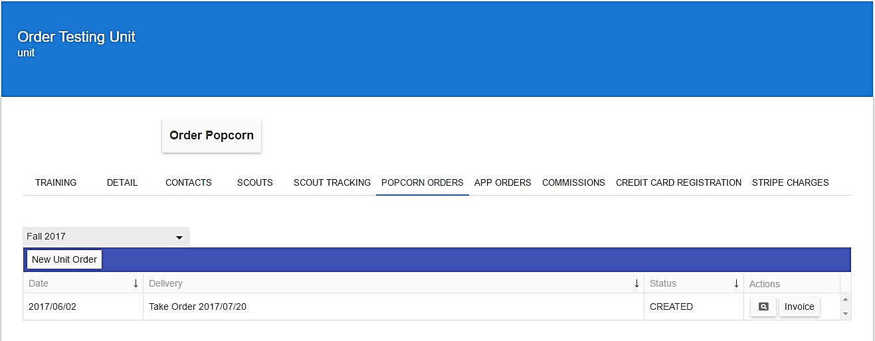

Tracking Scout Sales
Simple Sales Tracking for Store Front Sales (Show N Sell)
Most Councils will configure the initial order of the season so Units can pre-order products for store front sales. Because most units do not know at the time of ordering how much each Scout is sold, the simple sales tracking boxes allow a unit leader to return to the Scout Tracking page after placing the unit order and enter the dollar amount sold by each Scout. Type a dollar amount in the box that aligns with the Scout and the order. The boxes will automatically save the values entered.
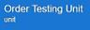
- From the unit homepage, click the Scout Tracking tab.
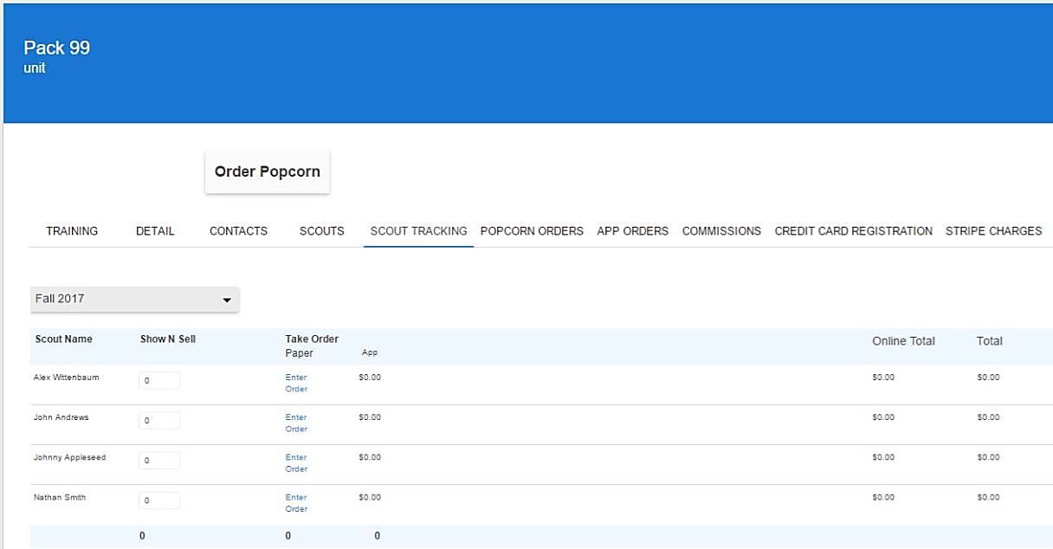
- Double check to make sure that the current campaign is set (This automatically defaults to the current year) to display the Scout Tracking fields.
- Next to each Scout’s name, enter the dollar amount sold in the empty allocation boxes.

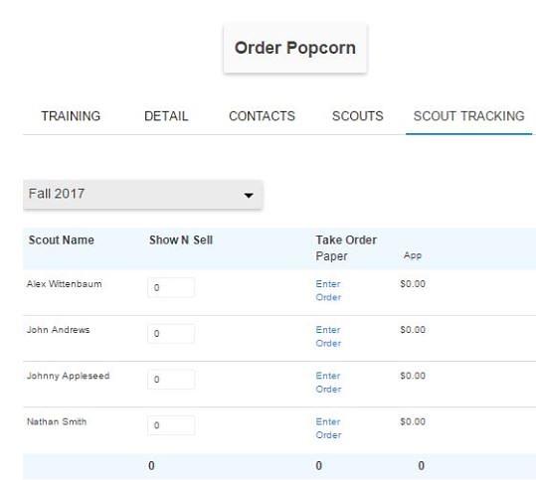
Take Order Sales Tracking
- Once you have entered all of your Scouts’ orders, the Enter Order hyperlinks will change to reflect the retail dollar amount sold by each Scout.

Online Sales Tracking
One of the many advantages of the new Popcorn System is it is directly synced with the online selling system. On the Scout Tracking page, there is a column titled Online Total that automatically calculates the total retail sales for each Scout that has registered an online selling account and sold to customers on Trails-End.com.

Online Selling
Using your same sign in credentials as the Popcorn System, log into the Trail’s End online selling platform at www.Trails-End.com to view Scout Sales, registered Scouts and invite Scouts to sell online.
