Day Camp Placemats (Free for your unit!)
Are you looking for table decorations for your pack’s Blue and Gold or want to spread the word on local day camps to your pack?
Order regional placemats promoting 2019 Cub Scout Camps. These placemats are 11x17 with photos and activities along with a list of all the camp dates offered this summer by region. The placemats are available at no cost to the pack. Orders can be picked up at any council service center.
Please fill out the form below and return to Elizabeth.Belter@scouting.org. Please give the council a 2 week notice for printing. Placemats will be ready for pickup beginning of January 2019. Please be conservative when placing orders. Thank you.
District____________ Pack Number ______ Blue and Gold Date___________________
Amount Needed_______ Pack Contact _________________________ Phone_______________
E-Mail Address____________________________________________________
Pick up location ___ MacArthur Service Center (St. Louis) ___ Cohen Service Center (Belleville)
___ Ritter Service Center (Cape Girardeau) ___ So. Illinois Service Center (Herrin)
____ Decatur Service Center
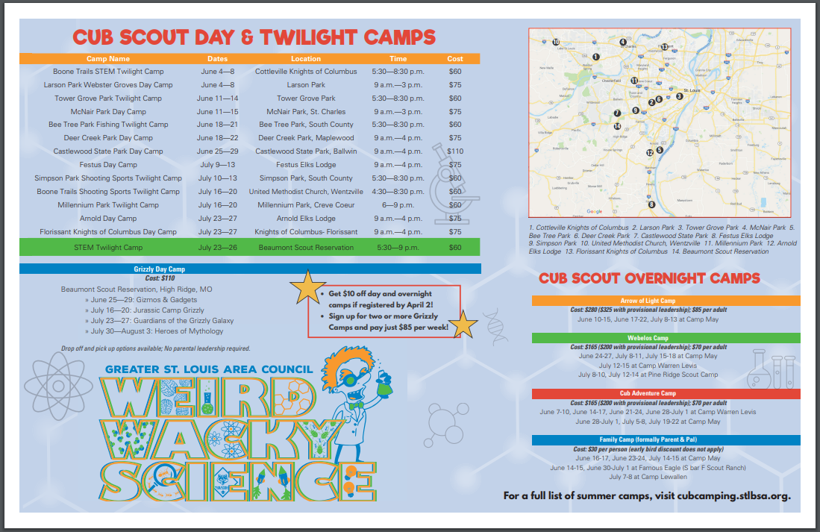
SAMPLE PLACEMAT FROM LAST YEAR
**** NEW**** All placemats this year will be by region based on your district***

