2019
Family friends of scouting
guide for volunteers
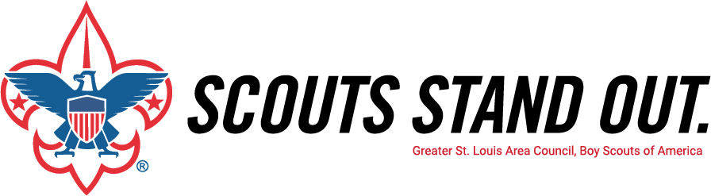

Welcome!
Thank you for helping the Greater St. Louis Area Council, Boy Scouts of America.
Together, we will raise funds to provide a positive Scouting experience to tens of thousands of youth members across eastern Missouri and southern Illinois. This guide will help you make a compelling case for potential donors to contribute to the 2019 Friends of Scouting campaign.

Remember: your knowledge, enthusiasm, and commitment to Scouting is important when securing contributions. You are raising funds that will positively affect our children and future generations.
Table of Contents___________________________________

Campaign set up
Outline 3
Who does what? 4
Plan of Action 8
Materials List 10
Samples 11
Recognition Items
Types & Differences 13
Individual Incentives 14
Unit Incentives 16
Resources
Presentation Guidelines 17
Optional Scripts (with & without FOS video) 20
What does the Council do for Units? 24
Council Contact List 29
Highlights of what Scouting has done! 30
Managing Objections 31
Presentation Day
Pre-Presentation Checklist 33
During Presentation 34
After the Presentation 35

https://stlbsa.org/give/friends-of-scouting/fos-resources/

Outline________________ _______________

- Schedule all Unit presentations.

- Forward all information to the Family FOS Chair.

- Contact the Unit Leader/Coordinator. (14 to 21 days prior to presentation)

- Give presentation. Ten Minute Guarantee

- Get Unit Report Envelope to District Executive. (within 24 hours)

- Follow-up with Unit Leader/Coordinator.

Who does what? ______________________________

District Family FOS Chair
Position Description
Principal Responsibilities
- Report to District FOS Chair.

- Recruit and train Crew Chiefs (aka Vice Chairs) by November 15th. Submit names and contact information to your District Executive.

- Recruit and train Trailblazers/Presenters by December 7th. Submit names and contact information to your District Executive.

- Promote and explain the Family FOS program at your District’s Roundtable in October, November, December and January.

- Schedule presentations at all Units by January 11th.

- Attend Chair Orientation and Kickoff November 28th.

- At December Roundtable, conduct Unit Coordinator Training and set the example by enrolling as a Friend of Scouting.

- Attend Council Report Meetings:
  - 25% Conference Call- February 27th
  - 50% Report Meeting- March 27th
  - 75% Conference Call- April 24th
  - Victory Celebration- May 31st

- Lead team of Crew Chiefs (area chairs), Trailblazers (presenters) and Unit Coordinators through regular communication and organized clean-up to 100% goal achievement by targeted date of May 31st.

Note
Your District Executive serves as your Campaign Advisor and will assist you throughout the entire campaign. You can contact your District Executive at the local Council Service Center.

Who does what? ______________________________

Family FOS Crew Chief (Area Chair)
Position Description
Principal Responsibilities
- Report to District Family FOS Chair.

- Assist in recruiting a full team of Trailblazers by December 7.

- Attend the District Training to be held _______________ where you will enroll as a Friend of Scouting.

- Make sure that your Trailblazers have made their Unit contacts and forward all Unit presentation dates to your Family FOS Chair by January 11.

- Supervise Unit presentations and communicate with your Trailblazers weekly throughout the campaign to cover upcoming presentations.

- Attend your District Report Meetings: TBD

- Council Report Meetings:

1. 50% Report Meeting- March 27th
- Victory Celebration- May 31st

Note
Your District Executive serves as your Campaign Advisor and will assist you throughout the entire campaign. You can contact your District Executive at the local Council Service Center.

Who does what? ______________________________

Family FOS Trailblazer (Presenter)
Position Description
Principal Responsibilities
- Report to District Family FOS Chair or Crew Chief.

- Attend the District Training to be held _______________ where you will enroll as a Friend of Scouting.

- Contact your Unit FOS Coordinators and set dates for all Unit presentations by January 11.

- Work with Unit FOS Coordinators to establish goals and plans for each Unit, including advance information to all families.

- Make your Unit presentations and follow-up with absent members and families throughout the campaign.

- Ensure that every family is asked to contribute.

- Attend your District Report Meetings: TBD

- Council Report Meetings:
1. 50% Report Meeting- March 27th
- Victory Celebration- May 31st

Note
Your District Executive serves as your Campaign Advisor and will assist you throughout the entire campaign. You can contact your District Executive at the local Council Service Center.

Who does what? ______________________________

Unit FOS Coordinator
Position Description
Principal Responsibilities
- Work with your Family FOS Chair, Trailblazer, and executive to set your Unit’s goal.

- Attend your district Unit FOS Coordinator training in December.

- By November 1, contact your Unit leader and committee to schedule the date for your FOS presentation. Presentations should occur by April 30 at a family event (Pack Blue and Gold or Troop Court of Honor). Report your Unit’s presentation date, time, and location to your Family FOS Chair or executive by January 11.

- By December 15, during charter renewal, generate a current roster of Unit leaders and families. Develop a list of Unit alumni (Arrow of Light recipients, Eagle Scouts, former adult leaders, etc.). Include family name, address, telephone number, and email address.

- One month prior to the presentation, contact leaders, families, and alumni to support the campaign presentation, announce the Unit’s goal and build awareness, enthusiasm, and commitment. Examples: Unit website, email, letter, or newsletter (templates provided).

- At the presentation, provide a warm introduction for the Trailblazer and assist with the presentation and physical arrangements. Presentation should be at the beginning of the event. Set the pace by publicly make the first Friends of Scouting gift. Track event attendance compared to your Unit roster and the pledge cards received. Announce progress toward goal and thank families.

- Ensure that all recognition items are distributed.

- Within two weeks, personally follow-up with absent families and those who did not return a pledge card. Ask them to give. Turn-in those pledge cards to your Family FOS Chair or executive. Continue to follow-up until every family has the opportunity to give.

Note
Your District Executive serves as your Campaign Advisor and will assist you throughout the entire campaign. You can contact your District Executive at the local Council Service Center.

Plan of Action ______________________________
- Schedule all Unit presentations.

The first step in the campaign is to schedule all Unit presentations. Some Units may have already submitted preferred presentation dates. Confirm the dates, schedule remaining presentations, and forward everything to the Family FOS Chair by January 11.

Presentations should occur between November and April when a majority of the Unit’s families are present (preferably Blue and Gold Banquets for Packs and Courts of Honor for Troops). It is strongly encouraged to avoid Pinewood Derbies. If possible, schedule presentations with Troops that conduct large end of the year Courts of Honor - this may be the last opportunity before the end of the campaign.

- Forward all information to the Family FOS Chair.

- Contact the Unit Leader/Unit FOS Coordinator. (14 to 21 days prior to presentation)
- Confirm the date, time and location of the FOS presentation. Also inquire about the number of families expected at the meeting and the A/V and physical arrangements if you plan to use the video.

- Ask Unit Leader/Coordinator about contacting all families to let them know about the presentation and the Unit’s goal.

- Secure the Unit Leader/Coordinator’s commitment to introduce you (optional script) including making the “First Gift” as their personal endorsement of the campaign.

- Explain the “Ten Minute Guarantee” – your presentation and card collection will take ten minutes or less (introduction, presentation, and collection). Be sure to abide by your promise.

- Ask to be at the beginning of the agenda. This will allow you to reach the most
people and give the necessary time to review pledge cards, prepare recognitions, etc.

- Ask about some of the Unit’s positive experiences in order to customize your presentation.

- Explain the brochure distribution and collection plan, and how you will need the assistance of Den Leaders, the Scoutmaster, or Scouts (preferably Scouts) during your presentation.

- Outline the Unit Recognition Items.

- Determine with the Unit Leader/Coordinator the best follow-up plan for absent families. The follow-up plan is critical to the success of the Family FOS campaign.

1. Mail – Use the sample letter with the Unit Leader/Coordinator’s endorsement and signature.
2. Call Night – With Unit leadership help call absent families and enroll their support.

Plan of Action ______________________________
- Give presentation. Ten Minute Guarantee
Arrive 20 minutes early and:
- Review with Unit Leader/Coordinator information about the Unit that is in your presentation (item f above).
- Review with Unit Leader/Coordinator your introduction and making the “First Gift”.
- Confirm arrangements to have Friends of Scouting brochures and any other promotional material distributed at the beginning of your presentation and collected by the conclusion. This should be done by Den Leaders, Scoutmasters, or preferably Scouts. DO NOT attempt to collect them yourself or have families bring them to you individually.
After your introduction: Ten Minute Guarantee
- Follow the prepared script optionally using the video.
- Present the participation ribbon to the Unit.
- Explain the free rank advancement incentive and announce the dollar goal needed to achieve this incentive.
- Explain how cards are to be filled out and all cards should be signed.
- Explain the different methods of payment:
Checks – make payable to the Greater St. Louis Area Council, BSA.
Credit Cards – include card number, expiration, address, and signature.
Pledge – there are various billing choices (4 payments of just $51 will support Scouting at the 1 Scout giving level).
Matching Gifts – explain the value of these gifts. Many matching companies are listed in FOS brochure.
- Instruct families to place the pledge card back into the envelope and return it regardless of their ability to make a gift. Before you return to your seat, collect all cards from those assisting.
- Thank the group for their support, and recognize the Unit Leader/Coordinator.
- If possible, leave extra brochures with proper District name and Unit number on them with a designated volunteer for personal follow-up. Arrange to pick them up within two weeks.
- Get Unit Report Envelope to District Executive. (Within 24 hours)
If pre-printed pledge cards were provided, please match all pledge cards with a pre-printed pledge card. Then group all of the pledge cards and payments together and secure with a paper clip (please do not staple) before placing them in the Unit Report Envelope.
Fill in any information on the Unit Report Envelope that is not already complete.
Make sure the dollar amounts on pledge cards and Unit Report Envelope are the same.
Get the Unit Report Envelope and all its contents to your District Executive with 24 hours.
- Follow-up with Unit Leader/Coordinator.
Complete the arranged pickup with the designated volunteer doing personal follow-ups. Execute your District’s follow-up plan.
Materials List ______________________________
FOS Materials List
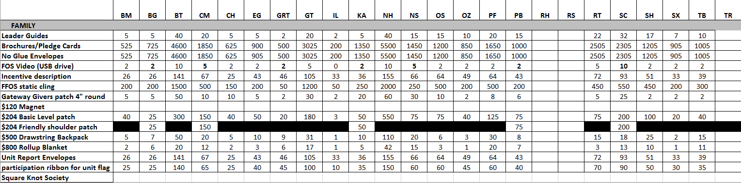
Samples ______________________________
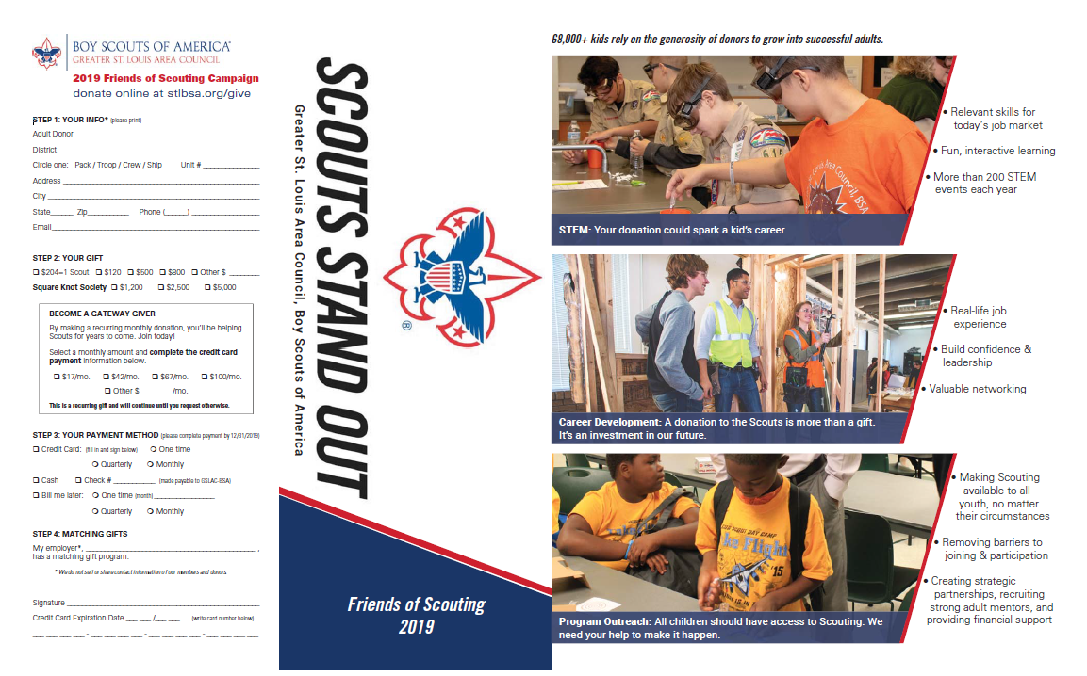

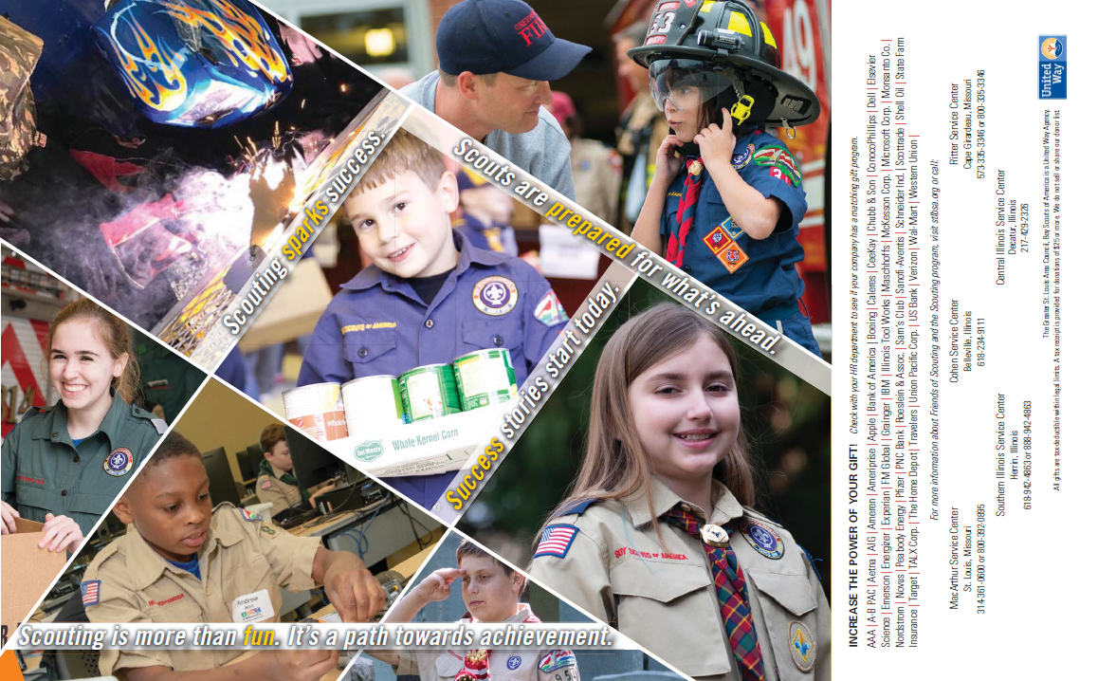

Samples _____________________________________________
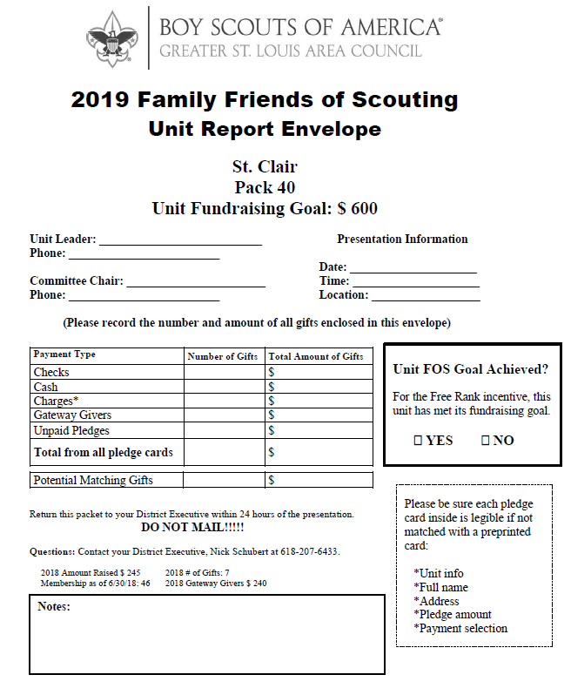

Recognition Items ______________________________
Types & Differences

There are 2 types of Recognition Items for Family FOS:

Individual Recognition Items -- Family FOS Static Cling
*for any participation in the Family FOS campaign
Magnet
*for $120+ participation in the Family FOS campaign
Family FOS Patch
*for 1 Scout giving level participation in the Family FOS campaign ($204+)
Drawstring Backpack with Logo
*for $500+ participation in the Family FOS campaign
Roll-up Blanket
*for $800+ participation in the Family FOS campaign
Square Knot Society Shoulder Patch, Pin, Certificate
*for $1200+ participation
Gateway Givers Family FOS Patch
*for monthly recurring donors ($17+/month)
Unit Recognition Items -- Participation Ribbon for Unit Flag
Free Rank Advancement from 4/1/19 to 3/31/20
(*free rank advancement patches for Scouts)
*for achieving 2019 base goal
Free Rank Advancement PLUS from 4/1/19 to 3/31/20
(*free rank advancement patches PLUS free REQUIRED Adventure Loops and Pins for Cub Scouts and Webelos, and free EAGLE REQUIRED merit badges for Boy Scouts)
*for achieving 2019 stretch goal

Recognition Items ______________________________
Individual Recognition Items for Donors

at any giving level
static cling
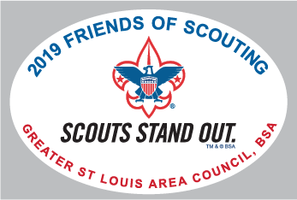

at the $120+ level
magnet
at the 1 Scout giving level ($204+)
3” round FOS patch with loop
at the $500+ level
Drawstring backpack with logo
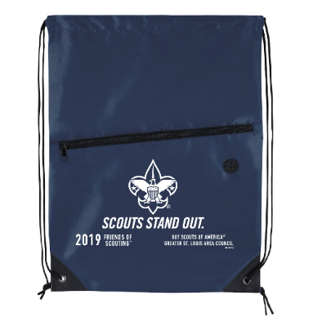

at the $800+ level
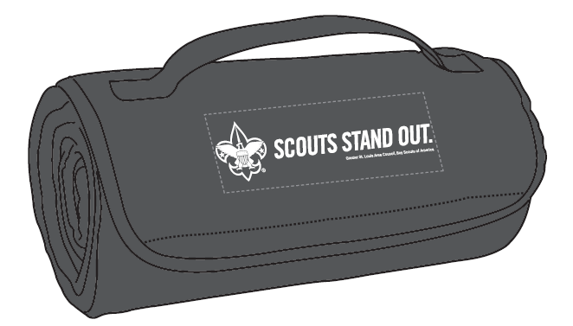
Roll-up blanket

at Square Knot Society giving levels ($1,200+)
Council shoulder patch, pin, certificate
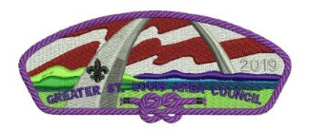

Gateway Givers
4” round patch with loop

Recognition Items ______________________________
Square Knot Society
Purpose:
- Provide donors with a deeper connection to the Greater St. Louis Area Council.
- Provide donors a chance to interact with other donors in a social setting.
- Let donors know the difference they are making.
- Give donors benchmarks to reach for to increase gifts.
Why the Square Knot Society?
The Square Knot is known as the joining knot in Scouting. It is symbolic of joining people together for a purpose. It is one of the first requirements that a Scout needs to pass in joining. It is also the symbol that we use to recognize leaders in Scouting. The members of the Square Knot Society are the key to helping build an organization that attracts more members and this society would stand as recognition for those individuals.
Implementation:
- Square Knot Society monthly update email.
- Square Knot Society holiday cards mailed from the Council.
- Square Knot Society events throughout the year.
- Lapel Pin indicating their giving level in the Square Knot Society.
Giving levels within the Society:
- Fleur-de-lis Level: $1,200 per year
- Scroll & Knot Level: $2,500 per year
- Two Star Level: $5,000 per year

Gateway Givers
Give a little each month to make a big difference!
A monthly recurring donation is the easiest and most convenient way to support Scouting. Because your gift renews automatically, we don’t need to send reminders. That saves money on paper, postage, and phone calls – putting more of your donation toward providing excellent programs for Scouts. It also provides a reliable stream of support that leads to better budgeting. You may change or cancel your contribution at any time.
Sign up for monthly recurring giving ($17+/month) and receive a commemorative Gateway Givers patch.

Recognition Items ______________________________
Unit Items

The Unit Report Envelope includes the base fundraising goal. Please explain this incentive and goal to qualify as part of your presentation. The stretch fundraising goal is $100 X membership as of June 30, 2018.

Unit dollar goals were established by a one on one conversation of each Unit Leader with their District Executive or District FOS Chair. If there is no amount for last year, then each FOS Chair chooses a goal amount based on the number of active Scouts.

Free Rank Advancement Incentive
When a Unit achieves its base fundraising goal, it qualifies to receive free rank advancement patches for all their Scouts for a year. This is effective from April 1, 2019 to March 31, 2020.
This includes Tiger, Bobcat, Wolf, Bear, Webelos, and the Arrow Light patches for the Cub Scout program. Boy Scout patches include Scout, Tenderfoot, Second Class, First Class, Star, and Life. The Eagle badge and presentation kit are provided to qualified candidates through other funding sources. Venturing awards that qualify are the Pathfinder Award, the Discovery Award, and the Summit Award patches.

Free Rank Advancement PLUS Incentive
When a Unit achieves its stretch fundraising goal, it qualifies to receive free rank advancement patches PLUS required Adventure loops and pins or Eagle required merit badges for all their Scouts for a year. This is effective from April 1, 2019 to March 31, 2020.
This does not include electives.

Resources __________ __________________
Presentation Guidelines
The information below shows donors (1) your competence as a fundraiser, (2) your awareness of their participation and appreciation for their gift, and (3) your commitment to Scouting.

Summary of Program
Friends of Scouting is the Greater St. Louis Area Council’s annual fundraising campaign. Just as your church and other organizations must do, we solicit our membership to support the Scouting program of the Council.

Friends of Scouting contributions provide such things as the Duffle Bag (the Council’s Newsletter), the Council Service Centers, the camp facilities and their maintenance, help and materials for Unit organization, planning, recruitment, training, and activities. It also includes the personnel in each department who serve in support, guidance, and resource roles to the Unit, District, and Council level volunteers.

The Presentation
Your presentation is only one item on the agenda of an important and carefully planned meeting for this Unit. Be considerate of their time and do a professional job with your presentation. Be prepared by contacting the Unit ahead of time and covering the items in your “Plan of Action”. The bullet points below serve as a guide for the presentation you develop.
Give the Unit Leader/Coordinator the scripted introduction when you arrive for the meeting. Your presentation should not take longer than 10 minutes. This “Ten Minute Guarantee” includes the time spent distributing and collecting pledge cards. Share a story reflective of your own experiences, telling how Scouting has impacted your life or the lives of those around you.
Before you arrive at the first presentation of the campaign, make yourself a Friend of Scouting – make a donation. It is much easier to ask others to do what you have already done.
The ultimate goal of this campaign is to raise money, but also to raise awareness of Scouting’s value enriched programs. Be familiar with the facts about Scouting and this Council. The Council serves one in every five youth so every person you are addressing is likely to know someone in Scouting or have been personally influenced by Scouting. Each donor should leave feeling good about having made a significant investment in Scouting and having made a difference in the lives of youth.
- Thank the Unit for having your presentation.
- Distribute brochures. Use Den Leaders, Scoutmasters, or Scouts at meetings.
- Explain why you are there.
- Tell three to four minutes of your story.
- Talk about the Council and its services.

Resources _______ _____________________

- Talk about the programs they have participated in and can look forward to.
- Talk about the Council’s camps.
- Continue your story relating it to the Council. (one minute)
- Give them a sense of Scouting’s history. Ensure the legacy continues through annual financial contributions.
- Explain that the Council receives no government funding.
- Explain that 100% of their registration fee goes directly to the National Office.
- Refer to the brochure.
- Discuss matching gifts, a list of matching companies is located on the brochure.
- Thank the donor for last year’s gift.
- Suggest that the donor consider increasing their gift to the next level.
- You may make a pledge or pay with check, cash, or credit card.
- All cards must be signed.
- Explain pledges and billing. All pledges and balances due may be billed one of three ways, one-time (after processing), quarterly (after processing, June, August, and October), or monthly (after processing through December).
- Emphasize that four payments of just $51 each will support the Scouting program for one year.
- Ask each family to return their pledge card to the Den Leader, Scoutmaster, or Scout confidentially in the envelope provided.
- Explain how matching gift programs help. If their employer participates, indicate on card and ask donor to follow-up with employer’s Human Resources Department for completion.
- Explain the free rank advancement incentive and how that can benefit the Unit. Share with the parents the Unit target goal to achieve this incentive.
- Those who prefer to take a card home and make a gift in the future should get another card from you and turn in the card they now have.
- Do not sit down until all cards have been collected.
- Conclude your story.
- Thank the Unit again for welcoming your presentation and thank donors for their contributions.
Some potential givers may have objections or questions. Listen to what they have to say. Most objections are based on misconceptions that can be cleared up by giving the correct information.
Donors can give online at www.stlbsa.org/give.

Resources __________ __________________
Trailblazer Introduction
delivered by Unit Leader/Coordinator

Once a year, a special guest visits us to make a Friends of Scouting presentation. Like us, ____(full name)_________________ is a volunteer Scouter representing the Greater St. Louis Area Council. __(first name)______________ is active in our district and in Scouting as a ___(volunteer position and unit affiliation)________________________. ___(your unit type and #)_______________ receives important services from our Council, and tonight is our opportunity to do our fair share of supporting the Council through becoming Friends of Scouting. To demonstrate this, I want to make the “First Gift” of our Unit’s campaign (give check and pledge card to Trailblazer). Last year, our families gave a combined $___________, and I’m hopeful that this year we’ll do even better. Now please welcome _____(full name)____________________________.

Resources __________ __________________
Optional Script – with FOS video
Trailblazer Opening Remarks:
Thank you for giving me a few minutes of your time. Kids in Scouting have a lot of fun and learn a lot along the way. You are watching your child do a lot of growing up in Scouting; learning skills, developing positive values, helping others, and shouldering responsibility. Each parent, and all of the leaders, have worked together to offer our children opportunities they couldn’t have anywhere else. But none of this just happens.
Begin video here:
When video stops:

Join me and invest in Scouting by becoming a Friends of Scouting contributor. Friends of Scouting provides the many services offered to support your Unit’s program such as training, insurance, program helps, advancement materials, camping facilities, and keeps the cost of Council and District activities affordable. The cost of services invested for each Scout enrolled in the Greater St. Louis Area Council is $204. This is a tremendous bargain when you compare it to the cost of baseball, soccer, hockey, or other youth leagues that don’t offer the same level of adventure and character development as Scouting. As an incentive for your generous giving, if your Unit achieves its goal of $___________ your Unit will qualify for free rank advancement patches for an entire year. As you consider your pledge, remember you don’t have to pay tonight.
Instructions for completing the pledge card:
Please use a pen as you enter your gift amount and be sure to sign the signature line. You may charge to either MasterCard, Visa, Discover, or AmericanExpress. If using a credit card, be sure your credit card number and expiration date are correct. Your signature is necessary to authorize all contributions. We are located in the _____________District and you are members of (Pack or Troop) _________. Print your name, address, and phone number on the appropriate lines.

Resources __________ __________________
For those who prefer to receive reminders, fill in the total contribution box and check your preferred billing option. Please note that four payments of just $51 each will support the Scouting program for one year.
You can increase the power of your gift! Many companies have matching and other employee recognition programs. These are great ways for employers to recognize contributions and involvement within Scouting. If you work for a company that makes matching gifts, indicate so on your card, please visit your employer’s Human Resources department to complete the appropriate paperwork, and then forward it to the Council office. They will handle the rest.
Now that you have completed your card, please turn it in confidentially in the envelope provided to your Den Leader (Packs) / Scoutmaster (Troops) who is collecting the cards. If you prefer to make a gift in the future, I will be happy to give you another card to take home, but turn in the card you’ve been given now.
Ask Den Leaders / Scoutmaster if they have all the cards back.
Do not sit down until all cards have been returned
Once again, I’d like to thank you for this opportunity to tell you about our Council and your Scouting program. Scouting is providing the youth of our community and our country the values necessary for them to develop a good, strong character. Thank you for making Scouting possible for your sons and other young people.

Resources __________ __________________
Optional Script – Without FOS video
Trailblazer Opening Remarks:
Thank you for giving me a few minutes of your time. Youth in Scouting have a lot of fun and learn a lot along the way. You are watching your child do a lot of growing up in Scouting; learning skills, developing positive values, helping others, and shouldering responsibility. Each parent, and all of the leaders, have worked together to offer our children opportunities they couldn’t have anywhere else. But none of this just happens.
I know of a boy who grew up in Scouting…
I encourage everyone to join me in investing in Scouting and become a Friends of Scouting contributor. Your contribution will help ensure the future programs and success of the Greater St. Louis Area Council.
Please complete the pledge card in your brochure now. Remember, the cost of services invested for your son and all registered Scouts by the Greater St. Louis Area Council is $204. This is a tremendous bargain when you compare it to the cost of baseball, soccer, hockey, or other youth leagues that don’t offer a well-rounded, values-based, character development program like Scouting. As an incentive for your generous giving, if your Unit achieves its goal of $___________ your Unit will qualify for free rank advancement patches for an entire year.
Instructions for completing the pledge card:
Please use a pen as you enter your gift amount and be sure to sign the signature line. You may charge your gift. If using a credit card, be sure your credit card number and expiration date are correct. Your signature is necessary to authorize all contributions. We are located in the _____________District and you are members of (Pack or Troop) _________. Print your name, address, and phone number on the appropriate lines. For those who prefer to receive reminders, fill in the total contribution box and check your preferred billing option. Please note that four payments of just $51 each will support the Scouting program for one year.

Resources __________ __________________
You can increase the power of your gift! Many companies have matching and other employee recognition programs. These are great ways for employers to recognize contributions and involvement within Scouting. If you work for a company that makes matching gifts, indicate so on your card, please visit your employer’s Human Resources department to complete the appropriate paperwork, and then forward it to the Council office. They will handle the rest.
Now that you have completed your card, please turn it in confidentially in the envelope provided to your Den Leader (Packs) / Scoutmaster (Troops) who is collecting the cards. If you prefer to make a gift in the future, I will be happy to give you another card to take home, but turn in the card you’ve been given now.
Ask Den Leaders / Scoutmaster / Scouts if they have all the cards back.
Do not sit down until all cards have been returned
Once again, I’d like to thank you for this opportunity to tell you about our Council and your Scouting program. Scouting is providing the youth of our community and our country the values necessary for them to develop a good, strong character. Thank you for making Scouting possible for your sons and other young people.

Resources __________ __________________
What does the Council do for Units?
To help Unit Leaders, the Council maintains four service centers with clerical staff to:
1. Process registrations, Boys’ Life subscriptions, and special requests to the national office and other organizations.

2. Maintains a supply of literature, insignia, forms, certificates, etc., needed by the leader to carry on the Unit’s program.

3. Keep records of advancement, membership, training, etc., necessary to Unit operation.

4. The Council publishes a quarterly newsletter and a twice-monthly e-mail newsletter to keep leaders informed of latest local and national Scouting news, coming events, etc.

5. Produce notices, minutes, agendas, etc., for District and Council committees that are developing programs for leader and Unit benefit.

6. Handle phone calls and visitors for information related to Unit operation and Scouting procedures including toll free phone service.

7. Provide dozens of regular and special forms, applications, certificates and literature helpful in Unit program.

8. Produce District and Council calendars and schedules, programs, kits and special aids to assist leaders and their committees.

9. Make reservations for videos, equipment, long-term camping, short-term camps, camporees, jamborees, high adventure bases, training courses, meetings, Cub Scout Leader Pow Wows, Exploring activities, annual Council and District meetings, Troop leader and Den Chief events.

Resources __________ __________________
To Protect the Unit Leader, the Council:
1. Screens requests for services and money earning proposals, guarding against improper use of Scouting for commercialism and exploitation.

2. Maintains a liability policy for the protection of all leaders and chartered organizations.

3. Maintains accident and sickness insurance policy for all registered youth and leaders.

- Has staff members available on what is practically an around-the-clock, around-the-calendar basis to meet any emergency.

To help the Leader develop Unit Program, the Council provides without charge:

1. Program helps, program planning charts and calendar of activities, meetings and special
events.

2. Awards, such as ribbons, certificates, roundup awards, etc.

3. Fall recruitment, camporee, and Scouting Anniversary Week kits, posters and other
materials.

4. Sample song sheets, ceremonies, parent’s night program outlines, training aids, etc.

5. Source materials and personnel.

6. Materials, books, pamphlets, folders, videos and special helps from the National Council and cooperating organizations.

Resources __________ __________________
In the field of camping and outdoor activities, the Council:
1. Maintains Scout camps for year-round camping and Cub Scout family outdoor events. Our Scout camps serve as year-round activities, camping and training centers.

2. Offers Units the use of equipment for short-term, weekend, and year-round camping.

3. Budget covers costs of camp repairs, replacement, maintenance, insurance and administration.
These and other charges are not paid for by Scout’s fees.

4. Employs full-time camp rangers for the protection of the Scout Reservations and the convenience of Units using facilities. They keep these facilities available at all times.

5. Provides campers’ savings discounts, Unit leaders’ guidebook, camp videos, folders, literature and other aids to help Units with their program.

6. Provides scholarships or “camperships” for Scouts who need some help to have a summertime camp experience.

7. Offers Units the high adventure of Philmont Scout Ranch, high-adventure bases, national jamborees, field days, camporees and other special events. These would not exist without a Council giving leadership and coordination.

Resources __________ __________________
In Educational and Relationships Program, the Council provides the Leader with:
1. A library of DVDs, digital projectors and screens for use in training and promotional programs, at no cost to the Unit.

2. Informal and formal training courses with most of the cost of literature and materials, etc., and all the staff time included in the Council budget.

3. Monthly roundtables for the benefit of leaders, committee persons, assistants, and Den Leaders, providing materials, staff and other costs.

4. Scouter’s Key, training awards, Den Leader’s Training Award, Silver Beaver, and other Scouter recognitions.

5. A merit badge counselor corps in more than 130 subjects.

6. A variety of advancement forms and certificates without charge. These are processed in the thousands each year.

Providing the Unit with District and Council activities and service, the Council:
1. Plans and conducts various types of activities in which Units participate such as Scouting Anniversary Week and Scouting for Food.

2. Organizes camporees, Cub Scout day camps, Jamborees, high-adventure trips, Explorer events, absorbing overhead costs to keep participants’ expenses to a minimum.

3. Works with various community groups to arrange for Scout participation in civic affairs and Good Turn projects.

4. Recruits and trains a corps of commissioners for assisting with Unit program and
maintaining standards.

Resources __________ __________________
To assist Leaders, the Council employs a trained full-time staff who counsel, guide and inspire:
1. Through person-to-person counseling on Unit relationships, administrative and operational problems.

2. Through guidance of all committees, commissioners, roundtables, meetings, conferences, courses, district and Council activities in the development of programs that directly benefit leaders and Units.

3. Through contacts with the community resources (clubs, churches, government, etc.), secure help for all Units that they alone could not obtain. The use of parks, recreational areas, use of buildings for special affairs, picnic area, campsites, and swimming facilities are a few examples.

MacArthur Service Center
4568 West Pine Boulevard
Saint Louis MO 63108
314-361-0600 or 800-392-0895

Cohen Service Center
335 West Main Street
Belleville IL 62220
618-234-9111

BSA Outfitters
13347 Manchester Road
Des Peres MO 63131
314-984-0014

Ritter Service Center
3000 Gordonville Road
Cape Girardeau MO 63703
573-335-3346 or 800-335-3346

Southern Illinois Service Center
803 East Herrin Street
Herrin IL 62948
618-942-4863 or 888-942-4863
Central Illinois Service Center
262 W Prairie Avenue
Decatur, IL 65253
217-429-2326

Resources __________ __________________
Council Contact List

Team 1 (Grand Towers, Illini, North Star, and Thunderbird Districts)
Claire Nordmann Field Director, Team 1 314-256-3100 claire.nordmann@scouting.org
Timothy Lampley Grand Towers, District Executive 314-256-3090 timothy.lampley@scouting.org
Tori Smith Illini, District Executive tori.smith@scouting.org
Daron Storman North Star, District Director 314-256-3078 daron.storman@scouting.org
Khary Floyd North Star, Senior District Executive 314-256-3082 khary.floyd@scouting.org
William Humphrey Thunderbird, District Executive 314-256-3088 william.humphrey@scouting.org

Team 2 (Boone Trails, Cahokia Mounds, Osage, Piasa Bird Districts)
Carl Bobis Field Director, Team 2 847-772-1631 carl.bobis@scouting.org
Joey Stokes Boone Trails, District Director 314-256-3086 joseph.stokes@scouting.org
Kevin Beehner Boone Trails, District Executive 314-256-3102 kevin.beehner@scouting.org
Kevin Buhr Cahokia Mounds, District Director 618-207-6432 kevin.buhr@scouting.org
Bradley Hardin Cahokia Mounds, District Executive 618-207-6422 bradley.hardin@scouting.org
Ken Etter Osage, District Executive 314-256-3106 ken.etter@scouting.org
Nathan Mead Piasa Bird, District Executive 618-207-6429 nathan.mead@scouting.org

Team 3 (Gravois Trail, New Horizons, Pathfinder, River Trails Districts)
Claude Bond Field Director, Team 3 314-256-3024 claude.bond@scouting.org
Mike Eschbach Gravois Trail, District Director 314-256-3060 michael.eschbach@scouting.org
Zoran Lazic New Horizons District Director 314-256-3054 zoran.lazic@scouting.org
Ben Luedloff New Horizons District Executive 314-256-3132 benjamin.luedloff@scouting.org
vacant Pathfinder, Senior District Executive
Rebecca Long River Trails, District Director 314-256-3062 rebecca.long@scouting.org
Justin Crain River Trails, District Executive 314-256-3048 justin.crain@scouting.org

Team 4 (Black Gold, Egyptian, Kaskaskia, St. Clair Districts)
Mark Hays Field Director, Team 4 618-207-6435 mark.hays@scouting.org
Joe Blasko Black Gold, District Executive 816-225-6201 joseph.blasko@scouting.org
Lauren Schuette Egyptian, District Executive 573-450-9424 lauren.schuette@scouting.org
vacant Kaskaskia, District Executive
Matthew Kasate St. Clair, District Director 618-207-6425 matthew.kasate@scouting.org
Nick Schubert St. Clair, District Executive 618-207-6433 nicholas.schubert@scouting.org

Team 5 (Big Muddy, Cherokee, Ozark Trailblazers, Shawnee, Sioux Districts)
Jared White Assistant Director of Field Service 573-335-3346 jared.white@scouting.org
Nick Mertens Big Muddy, District Executive 314-210-2737 nicholas.mertens@scouting.org
Mindy Sanders Cherokee, District Executive 573-450-9983 mindy.sanders@scouting.org
Adam Hinds Ozark Trailblazers, District Executive adam.hinds@scouting.org
Ashley (Duerst) Metelski Shawnee, District Executive 314-920-0621 ashley.metelski@scouting.org
Michael Dineen Sioux, District Executive 573-778-7687 michael.dineen@scouting.org

Team 6 (Exploring and Learning For Life programs)
Tom Kroenung Director of Workforce Preparedness 314-256-3096 thomas.kroenung@scouting.org
Julie Monken Senior Exploring Executive 314-256-3052 julie.monken@scouting.org
Ryan St. Hill Exploring Executive 314-256-6444 ryan.st.hill@scouting.org
Ryan Kirchner Exploring Executive 314-256-3098 ryan.kirchner@scouting.org
Hannah Knapp Learning For Life Executive 314-256-3134 hannah.knapp@scouting.org

https://stlbsa.org/about/contact-us/

Resources __________ __________________
Highlights of what Scouting has done!

- 2019 is the 109th anniversary of the Boy Scouts of America.
- Our Council will invest $204 per youth member to provide a year of quality programs.
- Nearly 1 of every 5 available youth is enrolled in one of our programs.
- Throughout 63 counties in Missouri and Illinois, the Greater St. Louis Area Council serves over 68,000 youth.
- Nearly 15,000 adult leaders serve as uniformed role models.
- In 2018, 261 Scouts and Venturers completed National Leadership Youth Training (NYLT), the most of any Council in the Boy Scouts of America.
- 4,083 Greater St. Louis Area Council Boy Scouts attended 2018 summer camp at a council camp.
- Those Boy Scouts earned a total of 10,603 merit badges at 2018 summer camp.
- In 2018, 2,164 Cub Scouts went to a council Day Camp. 1,348 attended family or resident camp.
- In 2017, 763 young men achieved Scouting’s highest rank – Eagle Scout.
- Scouts collected 1.97 million cans of food during Scouting for Food in 2018.
- Digital Duffle Bag e-mail newsletter has more than 27,000 subscribers.

Resources __________ __________________
Managing Objections
Your sincerity and personal commitment are the best tools to use when responding to an objection. Since most objections are based on misconceptions, responding with, “If that weren’t an issue, would you consider making a contribution?” -- and providing the correct information – will usually overcome the objection and lead to a contribution.
Here are some tips to managing objections:
- Listen to what’s being said. Listening promotes openness and acceptance.
- Objections are not personal and may be a temporary stall until you establish rapport.
- Handle objections using the “Feel, Felt, and Found” method: “I understand how you feel. I’ve heard others who have felt the same way, and this is what I’ve found. If this wasn’t an issue, would you consider making a contribution?”
- Answer objections with facts.
- Leave with a smile and say, “thank you.”

Resources __________ __________________
FAQs
Q: I already give to the United Way. Doesn’t the Boy Scouts receive support from them?
A: The United Way provides 18 percent of the Council’s operating budget, encourages our fundraising efforts, and often measures the community’s commitment to Scouting by its response.

Q: How many youth will actually benefit from my contribution?
A: GSLAC served more than 68,000 youth members last year. The Council serves a 20 percent market share of all Scout-age youth.

Q: How much money goes directly to Scouting programs, and how much goes to administrative and fundraising costs?
A: 86 cents of each dollar raised is returned to members in the form of program. The not-for-profit standard for fund allocations is that 65 cents of every dollar be spent on program (source: U.S. National Better Business Bureau Standards for Charity Accountability).

Q: I live outside of Saint Louis; why should I give?
A: The Council provides services to Scouts and families throughout its territory of 63 counties in Missouri and Illinois, not only residents of the Saint Louis metropolitan area.

Q: I’m never going to use these services; so why should I give?
A: It is likely that you, a relative, or someone you personally know is directly impacted by the character building, citizenship training, and mental and physical fitness programs of the Boy Scouts of America. Your contribution helps keep their cost to be involved at a minimum.

Q: What if personal circumstances won’t allow donors to increase their gifts?
A: Acknowledge the donors’ circumstances and past generosity. Ask them to evaluate their gifts and give what they can.

Presentation Day_________ _______________
Pre-Presentation Checklist

- Presentation date, time, and location re-confirmed

- Physical and A/V arrangements confirmed

- Personalized introduction script

- Early agenda placement

- Unit leader will make “The First Gift”

- Customized presentation to include positive Unit experiences
Ten Minute Guarantee

- Arrangements made for distribution and collection of pledge cards

- Brochures / Pledge cards

- Pens

- Scripts

- Calculator

- Unit Report Envelope

- Individual Donor Recognition items

- Participation Ribbon for Unit Flag
Presentation Day ____________________________
During the Presentation

Ten Minute Guarantee

- Introduce yourself.

- Share some of the Unit’s positive Scout experiences.

- Share some of what Scouting has done.

- Give instructions on how to complete the pledge card.

- Share information concerning potential Matching Gifts.

- Give wrap up instructions.

- Say “Thank You.”

- Do not sit down until all cards have been returned.

Presentation Day ____________________________
After the Presentation

- Take all the gathered items to the side or back of the room where you will not disturb the program.

- Match the pledge cards with the corresponding check or cash to ensure that they do not become separated. Please do not staple cash or checks to the pledge cards.

- Be sure all the pledge cards have ALL the information on them and they are signed. ALL cards MUST be signed.

- Total the gifts. It can be helpful to sort gifts by cash, checks, credit cards, unpaid pledges, and matching gifts. Presentation Audit forms are available in Word and Excel.

- Let the Unit Leader/Coordinator know the total raised so they can announce it. Let them know if they have achieved their goal and Unit incentive.

- Make sure individuals receive their Recognition Items (from you or through the Unit Leader/Coordinator).

Note: If the Unit does not achieve any/all possible Recognition Items, encourage them to continue the effort. Explain that Recognition Items can still be achieved and received throughout the Family FOS campaign.

- Put all pledge cards and gathered funds into the Unit Report Envelope for return to your District Executive. Include the pledge cards with no gifts in this envelope. These families will be marked as worked and a follow-up letter will not be sent.

Get Unit Report Envelope to your District Executive within 24 hours of the presentation!!!!!
- Work with Unit Leader/Coordinator to follow up with individuals or families that were not present at the presentation.

