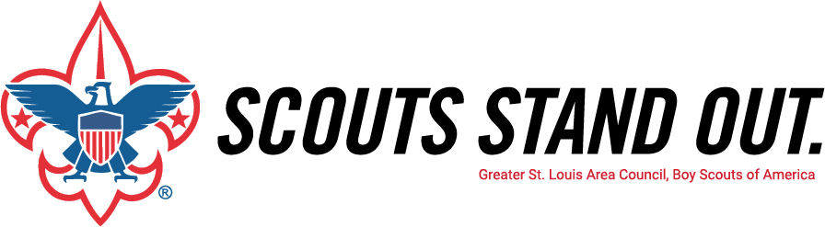

2019 Friends of Scouting
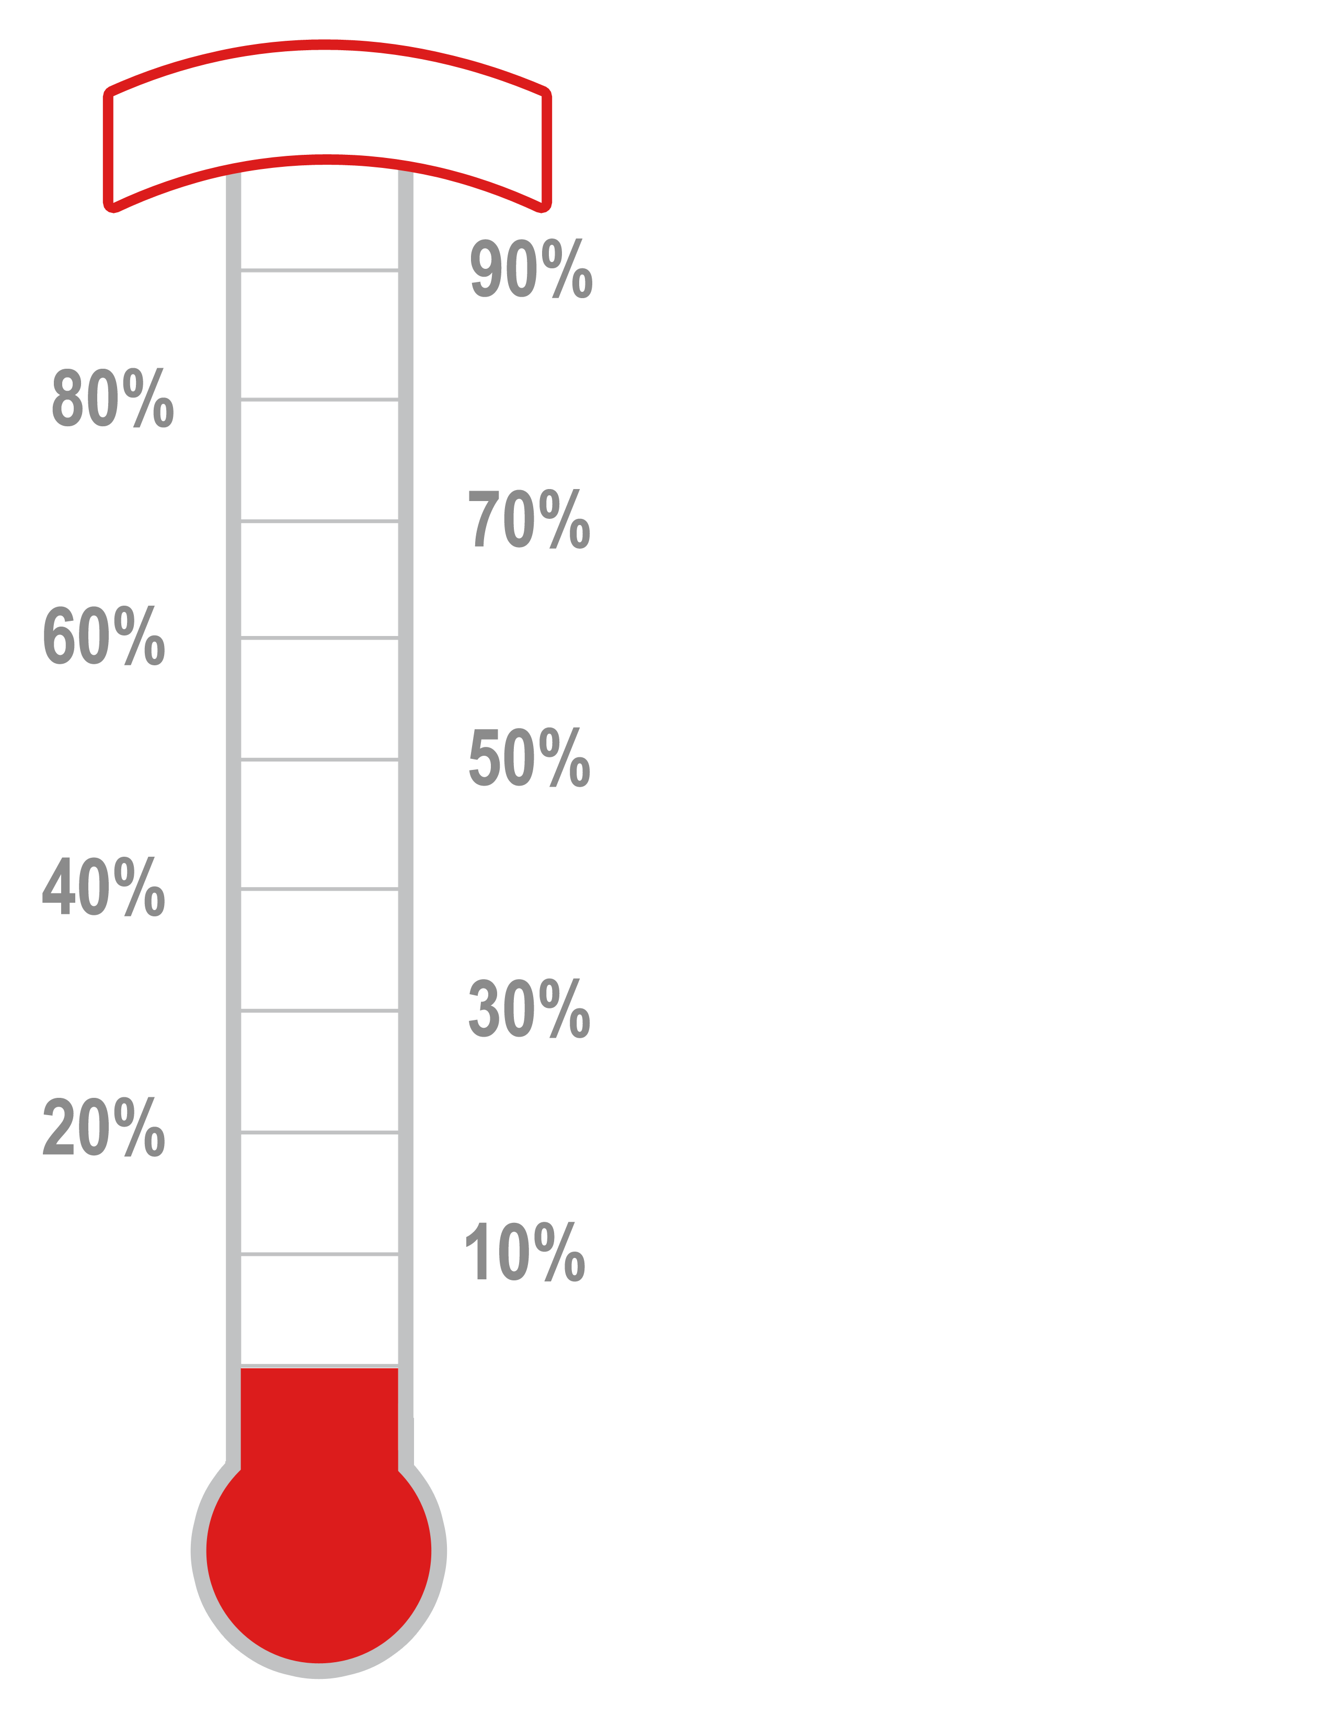
Unit _________________

