Youth | Estimated Costs
Youth Member Registration Fee – National Scouting | $75 – annual fee
New Member Joining Fee – National Scouting | $25* (one time fee for new Scouts)
Subscription to Scout Life Magazine | $15
Unit Program Fee(s)  *Advancement, Pinewood Derby Cars, Campouts/Activities, etc. | $ - annual fee
Uniform Cost – Estimated  ***Experienced Uniforms may be available - ask your unit leader.*** | $35 - $55 – shirt only  $90 - $110 – full uniform
Den Dues
Estimated Camping & Activity Fees
Estimated Total
Adults | Estimated Costs
Adult Member Registration Fee - National | $45 – annual fee
Uniform Cost - Estimated | $50 - $72– shirt only  $150 - $175 – full uniform
Estimated Camping & Activity Fees | $ - annual fee
Fall 2022
*Help is available. The Greater St. Louis Area Council is committed to ensuring all youth can experience Scouting regardless of their financial situation. Talk with your unit leader for more information.
Pack /Troop xxx
Program Fees

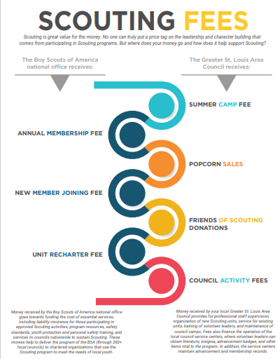
Fall 2022

