River Trails District

Klondike Derby

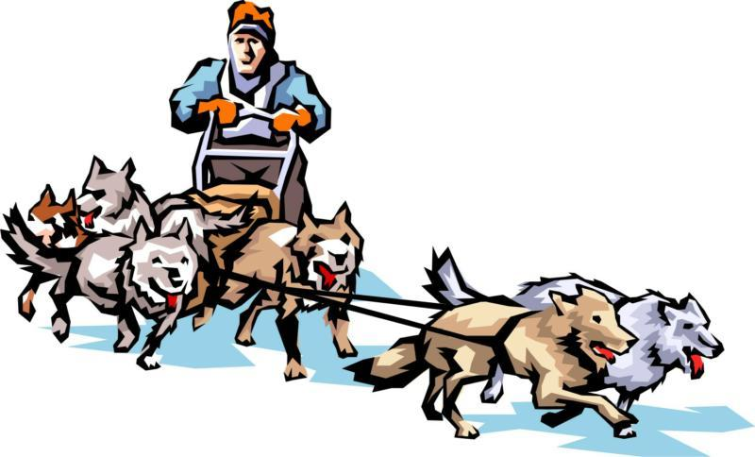

Through the Tundra

February 10, 2023

Greater St. Louis Area Council Boy Scouts of America

2023 River Trails District – Klondike Derby

Date: February 10, 2023

Location: Beaumont Scout Reservation – Nagel Area

Check-In: Registration for Klondike will begin Saturday morning from 7:00 am to 8:00 am at the Nagel Lodge. Please be prompt – we need time to finalize registration before opening. The Klondike will end at 5:00 pm after the races and awards presentation.

Cost: The Klondike fee covers the cost of a patch and all program materials. The cost is $8 per Scout and adult attending. Please send your payment with a registration form to the council office.

General: The Klondike is a one-day event. If your Troop/Crew is planning to camp for the weekend, you need to make a separate reservation with the camping department, for tent camping, Laemmli is reserved for River Trails. The event is a District Boy Scout event. Arrow of Light Scouts that are about to crossover may attend, but could be limited by The Guide to Safe Scouting from some events, and must follow age appropriate guidelines if camping. Other Cub Scouts and siblings will not be permitted at the event.

Adult Michael Stephens
Advisor: (314) 795-2272
michael.stephens@shawneelodge.org

Youth Miranda Machalek
Campmaster:
miranda.machalek@shawneelodge.org

Questions? Contact your Scoutmaster, your OA Troop Representative, Mike or Miranda.

Through the Tundra

PLEASE NOTE: The Scout patrols should plan on having their sled with them as they move about during the day as it will be required at some events. They should also have on the sled their lunches and supplies for the day. The lunch break is short, and Scouts won’t have time to leave the Klondike area, eat and get back. All patrols are to bring flint and steel, team spirit, and the ability to laugh !

Ice Melt Oh no! While on the trail your water bottles froze and now you must unfreeze them so everyone can stay hydrated. We will test your fire building skills as you compete to melt the ice faster than all the other patrols using just the flint and steel that your patrol brings. The previous trek that was here before has left behind all the wood you will need.

Blizzard Escape Our guide never took the Orienteering Merit Badge and got us lost in the snow storm, now using the patrol around, you must find your way out of the tundra.

Tundra Survival What could happen in the tundra? You will see and use your first aid knowledge to figure out the solutions to the scenarios given. The tasks will be randomly assigned to the groups for them to figure out how to get their scouts back to safety and get them medical treatment while in the harsh elements of the tundra.

Let it Snow Every snowflake is unique in its own way and while on the trail you have found some little and some big. Your task is to use your imagination to zoom in on a snowflake and recreate it using the knots and lashings you have learned along your scouting journey along with sticks provided.

Cross Cut Your crew has passed an icy spot on the trail and must get your persons and equipment across in a timely and orderly fashion. Using a two person saw you are going to create slices of a log to use as stepping stones. Don’t forget to keep these stepping stones to use for branding later on in the day.

Layer Up It seems to be getting quite colder outside! Make sure you are putting on layers to keep warm. Using the clothes provided and creating a strategy, the fastest team to put on all their layers will get bragging rights for the year and be able to say they are the most prepared for the cold.

Prepare For the Cold Shelter is needed for the night with a huge snow storm coming in. Using just cardboard and tape the group will make an igloo that will hold all persons on the expedition with them so that they can stay warm for the night.

SCHEDULE

Saturday

Registration | 7:00 am - 8:00 am | HQ – Nagel Lodge
Opening Assembly | 8:15 am | Nagel
Event Rotation | 8:30 am -9:15  9:20 am – 10:05 am  10:10 am – 10:55 am  11:00 am – 11:45 am | Nagel
Lunch | 11:50 pm – 12:40 pm | Nagel
Event Rotation (cont.)  Sled Races  Closing Assembly/Awards | 12:45 pm – 1:30 pm  1:35 pm – 2:20 pm  2:25 pm – 3:10 pm  3:30 pm – 4:15 pm  4:30 pm – 4:45 pm | Nagel  Nagel

SLED RACING RULES

Sled races will be held for two classes.
The younger class will be for Scouts aged 13 and younger.
The older class will be for Scouts aged 14 and older.
Scouts can only run in the appropriate class.
A Scout must be present all day to participate in the races.
Only registered Scouts are allowed to participate.

SLED CONSTRUCTION

1.The sled is to be 5-6 feet long by 18-24 inches wide with a comfortable handle height (approx 40”) for proper steering by the scouts.
2. The sled is to be made entirely of wood. No metal parts will be accepted. Lashings, and glue are the only acceptable binding and connecting materials.
3. One scout must ride in the sled.
4. One scout will steer the sled.
5. All other members of the patrol will be “mushers” pulling the sled with properly attached rope or harness.
6. Adults are encouraged to supervise the building of the sleds, but the sled must be entirely built by the patrol or troop. Any sled proven to be constructed by adults will be disqualified. A Scouter – as well as a Scout – is TRUSTWORTHY.
7. The sled may be of any design that meets these requirements.
8. A Patrol flag is required on each sled.
9. The patrol is encouraged to adorn or decorate their sleds as per the designated theme.

Be sure to follow the sled racing and construction rules to qualify for an award.

Awards
Awards presented in each class for the following:
- Best looking sled
- Best Design
- 1st Place - Older Class
- 2nd Place - Older Class
- 1st Place - Younger Class
- 2nd Place - Younger Class

Awards will be presented to the winning Patrol in each class.

CAMP RULES

- The event is a Boy Scout only. Cub Scouts and siblings will not be permitted at the event.

- NO alcoholic beverages.

- No smoking! Please refer to the Guide for Safe Scouting. If you must smoke, please move to the parking lot out of view of others, especially youth.

- No fireworks, firearms, bow, and arrow, etc.

- No pressurized fuel equipment (lanterns, stoves, heaters, etc.) unless you have taken the Greater St. Louis Area Council Training and have received your Toasted Chit and have it with you. Charcoal or wood is recommended for all cooking.

- No flames of any kind are permitted inside or near a tent.

- No heaters of any kind are permitted inside or near a tent.

- Kerosene lanterns may be used to illuminate the campsite. However, battery operated lanterns are much safer and shed much more light.

- Water sources are for filling water containers and drinking only, not for bathing or for washing the dishes. Please ask your scouts not to play with the faucets; this creates a muddy mess in a very short time.

- NO live trees may be cut. Please follow the Outdoor Code.

- Digging the ground around any tents are not allowed. Use proper pitching of tents to avoid ditching. Please follow the Outdoor Code.

- The BSA Guided to Safe Scouting allows sheath knives, the River Trails District Committee has voted not to allow possession, wear, or use of sheath knives by any youth or adult at district activities. There may be further restrictions based on state law, local ordinances or Council’s policy. A Totin’ Chip is required by a Scout to carry a folding pocketknife. These tools must be used safely and properly at all times.

CAMP ROSTER
Klondike Derby February 10, 2023
Beaumont Scout Reservation (roster due at time of registration)

TROOP/CREW: ______ DISTRICT: River Trails

Patrol Name: _______________

Name | Address | Phone Number | Age | Patch  ‘F’irst or ‘R’epeat

Patrol Name: ________________

Name | Address | Phone Number | Age | Patch  ‘F’irst or ‘R’epeat

Adults

Name | Address | Phone Number | Patch  ‘F’irst or ‘R’epeat

EVENT EVALUATION

Event:

Unit:

Contact Info:

What did the scouts like the best?

What should we keep doing?

What should we start doing?

What should we stop doing?

Other comments:

Troop Registration Form
River Trails
Klondike Derby 2023

The Klondike Derby registration fee is $8 per scout and adult. The fee includes program supplies and a patch. This registration form and fee should be turned into the council office before the event or at the event headquarters the day of the event.

Troop/Crew # ________ # of patrols _________

Registered by: Name: ___________________________________________
Address: ______________________________________________________
Unit Position: ______________ Email: _____________________________
Home #: (____) _____ - _______ Cell #: (____) _____ - _______
 | Number |  | Total
Scouts BSA |  | X $8
Adults |  | X $8
Total |  | X $8

Make Checks Payable to:
GSLAC BSA

Mail to:
Greater St. Louis Area Council
4568 West Pine Blvd., St. Louis, MO 63108

Attention:
River Trails Klondike Derby 2023

Account Number
1.6801.608.20

