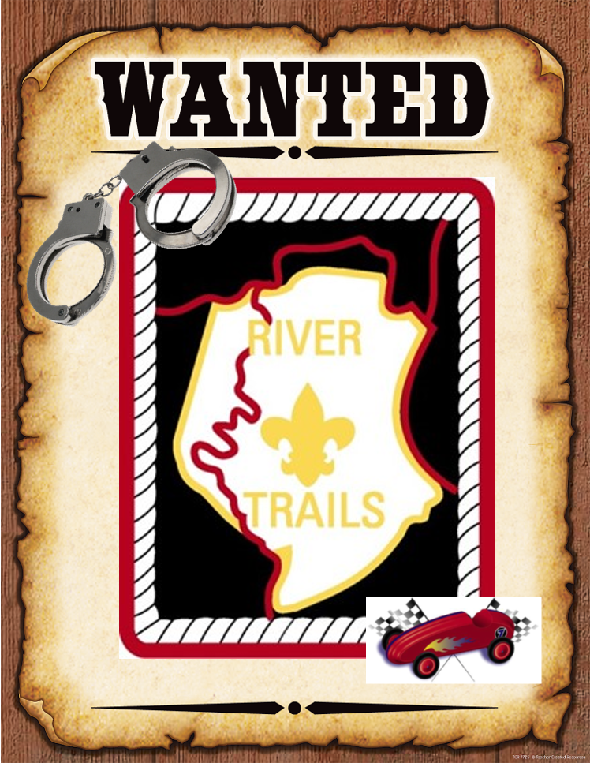

**River Trails District Pinewood Derby**

**Outlaw Division “Rules” of Engagement**

# Objective

The objective of the “Outlaw” Division is to allow for the construction and friendly racing of pinewood derby cars that are free of most of the limitations and restrictions placed on pinewood derby racers in the official Scouts BSA rules. This division is intended for both Scouters and family and friends of Cub Scouts as well as for Cub Scouts who want to build a second car for the purposes of racing in the Outlaw division.

# Purpose

A limited set of restrictions are needed in order to ensure the safety of racers, event staff, and spectators, and to ensure that race equipment is not damaged during the course of the race. This document defines these restrictions, provides rationale for why the restriction has been put into place, and how the restriction will be enforced. Pinewood derby cars found in violation of these safety restrictions will not be allowed to register for the race until the violations have been corrected. Race event staff will have final authority on findings of compliance for each Pinewood derby racer wanting to enter into the Outlaw division.

# Common Starting Point

All cars in the Outlaw division will start with the standard Scouts BSA Pinewood Derby racer block. Outlaw racers are not required to use the rest of the kit (wheels, axels, etc.) and may substitute preferred wheels and axels.

# Safety Restrictions

This section captures the safety restrictions for the River Trails District Pinewood Derby “Outlaw” division. All cars will be evaluated for compliance to these restrictions at registration. Cars found in violation of any of these restrictions will be barred from registering and racing until the safety restriction violations are corrected.

## Track Safety Restriction – Car Ground Clearance

All cars in the Outlaw division shall have sufficient ground clearance on the bottom of the racer to allow for the unrestricted movement of the car along the full length of the track. As a general rule, the required clearance for the car, in its racing configuration(s) along its travel down the track, is shown in Figure 3.1.1.

To ensure adequate ground clearance, race event staff will utilize the same dimensions check box used for standard Cub Scout Pinewood Derby races.



Figure 3.1.1: Minimum Ground Clearance for Outlaw Racers

## Track Safety Restriction – Car Width

All cars in the Outlaw division shall be sized to allow for cars to travel side-by-side down a standard pinewood derby track without causing interference to or derailment of other racing cars. As a general rule, the maximum width allowed for the car, in its racing configuration(s) throughout its travel along the track, is shown in Figure 3.2.1.

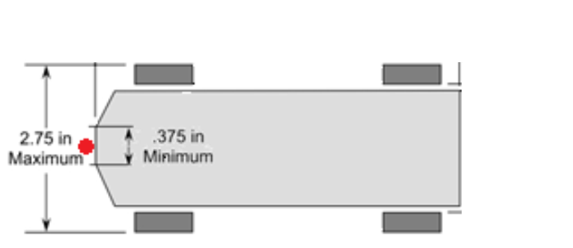

Figure 3.2.1: Minimum Ground Clearance for Outlaw Racers

To ensure the maximum car width is not exceeded, race event staff will utilize the same dimensions check box used for standard Cub Scout Pinewood Derby races for all cars registering for the Outlaw division. Additionally, racers are required to disclose to race event staff if their cars will undergo any planned transformations or other changes during the race that may cause the vehicle to change its width. Cars that undergo transformations during the race will be checked in their widest width configuration against the maximum car width safety restriction.

## Track Safety Restriction – Car Height

The “Outlaw” division will race on the same tracks as the Cub Scout and Akela divisions. These tracks have timing sensors at the end of the tracks that are housed in a metal bridge structure that is elevated above the track. In order to ensure the safety of the track, all cars that have heights that exceed those of the standard BSA Pinewood Derby stock car will be checked, by placing the car on the track and slowly rolling the car under the timing sensor bridge, to ensure clearance between the car and the timing sensor bridge.

If the car design includes transformations of the shape of the car during the course of the race, the person registering that car is required to disclose this design feature to race event staff. Vehicles that undergo transformations that change the height of the vehicle (even if the height change is only temporary), the car will be checked in its tallest height configuration to ensure clearance with the timing sensor bridge. If the car transformation yields a maximum car height could impact the timing sensor bridge, the car will be declared ineligible to race until the transformation mechanism is disabled.

## Track Safety Restriction – Material Transfer to the Track is Prohibited

Vehicles racing in the Outlaw division cannot transfer material to the track (such as oil, paint, glitter, sticky substances, or other materials that can damage or degrade the track) before, during, or after a racing heat. An exception to this rule is made for the use of standard graphite dry lubricants allowed per standard Scouts BSA Pinewood Derby rules. Additionally, material transfers caused by on-track collisions or car mechanical failures will not be cause for sanction of the racer(s).

Outlaw racers may use lubricants other than graphite for their cars, but are responsible for cleaning any material transfers from their vehicle to the track. Outlaw racers are also responsible for repairing any damage caused by material transfer from their vehicle to the track.

## Prohibited Design Element – High Energy Energetics

The use of energetic design elements is prohibited for racers in the Outlaw division. For the purposes of this restriction, the term “energetics” refers to design elements that utilize stored energy (other than gravity potential energy) or combustion to provide acceleration / force to the car. Elements that fall under this category include, but are not limited to, the following:

1. Compressed gas cartridges (CO2 canisters, compressed air canisters, or other compressed gas canisters)
2. Pyrotechnics (Fireworks, rocket motors, or anything involving combustion or explosions)
3. Ammunition components (Primers, gunpowder, or blanks)

Race event staff will have final say on whether a design element is considered to be a prohibited energetic. Cars with prohibited energetics will be barred from registering and racing until the prohibited energetic is removed.

Exceptions:

The following items are considered exempt from the High-Energy Energetics prohibition:

1. Springs used as part of a car transformation are not prohibited under this section so long as the Track Safety prohibitions are not violated by the transformation.
2. Mouse-trap type triggering mechanisms for vehicle transformations are not prohibited under this section so long as the Track Safety prohibitions are not violated by the transformation.
3. Compressed gas cars utilizing non-flammable, non-hazard gases will be allowed to race on a special track on a case-by-case basis so long as the special track is available. These cars will NOT be allowed to race on the official race tracks without permission from the owners of the tracks. Racers wanting to demonstrate compressed gas cars are required to coordinate these demonstrations with the race event staff before the day of the event.

## Race Staff Discretion – Safety of Track, Other Cars, and Spectators

Any car that proves to be hazardous during a race because of impingement of other racing cars, creating a safety hazard for race staff or spectators, or has a strong potential for causing damage to the track, will be prohibited from further racing. Race staff have final authority regarding determining if a car poses a hazard and should be prohibited from further races.

# Allowable Deviations from Standard Pinewood Derby Rules

This section captures a subset of the allowable deviations from standard Pinewood Derby rules allowed in the Outlaw division. As a general rule, so long as the design elements and final car design do not violate the prohibitions called out in Section 4, the design will be deemed acceptable to race in the Outlaw division. Some of the changes allowed in Outlaw division are as follows:

## Car Weight

Cars in the Outlaw division are allowed to exceed the 5.0 oz limit placed on cars in the Cub Scouts and Akela divisions. There is no official weight limit for Outlaw division.

Note: Heavier cars will have more energy (and thus more speed) on the straightaway portion of the track. The stop strips at the end of the track may not be able to “catch” the car if the car is travelling at to high of a speed. Race event staff are not responsible for any damage to cars caused by the car overshooting the stop zone at the end of the tracks.

## Car Wheels

Cars in the Outlaw division are allowed to use any type, number, alignment, camber and placement of wheels so long as the safety prohibitions in Section 4 are not violated. Racers are also allowed to modify wheels to their advantage so long as the Section 4 safety prohibitions are not violated.

## Car Lubrication

Cars in the Outlaw division are allowed to use any type of lubrication on the axels and wheels so long as the safety prohibitions in Section 4 are not violated.

## “Transformers”

Cars in the Outlaw division are allowed transform their shapes so long as the safety prohibitions in Section 4 are not violated. This allowance allows, for example, for cars to deploy extensions beyond the front of the body of the car in order to trip the timing sensor before the rest of the car crosses the finish line.

## Use of Body Kits / Additional Material

Cars in the Outlaw division are allowed to add material to the standard Scouts BSA Pinewood Derby Racer block so long as the safety prohibitions in Section 4 are not violated. Race event staff look forward to seeing the results of your creativity.