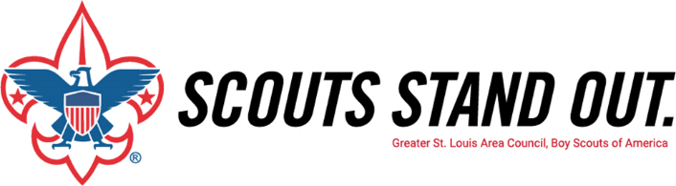
Unit Warm Up Letter & E-mail template

<<Date>>

Dear Parents of <<Scout Name>>,

In the coming months, our Unit will have a volunteer visit our our upcoming <<Blue and Gold Banquet/Court of Honor>> regarding the Greater St. Louis Area Council’s Family Friends of Scouting campaign. Friends of Scouting is our Council’s annual giving campaign. Our Scout’s Unit goal for 2022 is <<$>> and we are counting on YOU to help achieve 100% participation in the campaign. If we reach our goal we will receive Free rank advancement for a year!

What you may not know is the cost of providing our quality program per Scout is $225, which provides one year of our wonderful program for each Scout beyond our BSA registration fees – which go directly to our National BSA Office. We need your support this year more than ever to continue providing the highest level of quality program for our youth.

The annual Friends of Scouting campaign provides the direct support to operate our Council and our local District through:
- our camp properties, | - our service centers, | - our Scout Shops,
- membership recruitment, | - advancement, | - training,
- program outreach, | - scholarships | - accident insurance, and
- our wonderful staff.

Every gift is important to the success of our Scouting programs. There are opportunities for everyone to support the Family Friends of Scouting at a level that can help us along, propel us forward, or even leave a legacy. There are many ways to give to the Family Friends of Scouting Campaign through:
- a cash or check donation at the meeting,
- mobile giving or credit/debit card
- through a pledge made over time (monthly, quarterly, or semiannually).
- as a gateway giver; a monthly recurring gift that continues until you tell us otherwise. Get entered into a drawing for a free weekend at the beautiful Orthwein Cabins at S-F Scout ranch in Farmington, MO!

And don’t forget that you can multiply your support through your company’s matching gifts program.

The enclosed flier outlines some of our Council's achievements over the past year. As a Scout parent, you see first-hand, the benefits of Scouting and we hope you will consider giving to the campaign for 2022.

At our upcoming <<Blue and Gold Banquet/Court of Honor>>, I’ll be asking our Scout parents to contribute what you can to help us maintain and grow the quality program Scouting offers to your Scout and other youth in our community. I, myself, will be making a kickoff gift to help make our Unit’s goal and I hope you will join me.

Yours in Scouting,

Unit <<Unit Number>> Leader

E-mail template

At our upcoming Blue & Gold Dinner, we will have a volunteer visit us regarding the Greater St. Louis Area's Friends of Scouting Campaign; the Council’s annual giving campaign. Our Unit goal for the 2022 campaign is $xxx and I am counting on you to help us achieve 100% participation in the campaign. If every family donates we will reach our goal and the Unit will get FREE RANK ADVANCEMENT patches for the year!
The annual dues you pay go to National, not the local Council. Friends of Scouting goes to pay for a lot of unseen local costs that helps Scouting provide the most premier program for our youth. Those costs include:
-Camp properties for summer and weekend
-Activities and Programs for your Scouts
-Training and Courses for leaders
-Assistance to disadvantaged youth
-Membership recruitment and Advancement
-Service Centers and Scout Shops
-Accident and General Liability Insurance

Watch the campaign video here: https://youtu.be/8Xzz2nfTEFs
To donate online now, text Unit text code to 71777 or visit Unit URL
Thank you for your consideration; any amount helps local Scouting!

