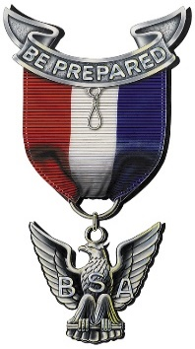
Southern Illinois NESA
of the
Greater St. Louis Area Council
Eagle Scout of the Year Nomination
Eligibility Requirement: The Nominee Must
- Be a registered, active member of a Scout Troop, Sea Scouts, or Venture Crew in one of the following Districts: Soaring Eagle, Black Gold, Piasa Bird, Kaskaskia, Cahokia Mounds, or Illini District.
- Receive/earn the Eagle Scout Award during the previous calendar year.
- Have demonstrated practical leadership and citizenship in his/her school, Scouting, and Community.
Submission guidelines
The nomination shall be submitted to the Southern Illinois National Eagle Scout Association committee of Greater St. Louis Council no later than 21st January of each year. All submissions need to be emailed to southernillnesa@gmail.com. The submission must include: this application, copy of the Eagle Scout Project workbook, and response to questions below highlighting the Eagle Scout’s demonstrated practical leadership and citizenship in their school, Scouting, and Community.
Nominee:
Name: Click or tap here to enter text. Unit Click or tap here to enter text.
Address, City, St., Zip: Click or tap here to enter text.
Age: Date of Birth: Click or tap here to enter text. Telephone: Click or tap here to enter text.
Date of Eagle Board of Review: Click or tap here to enter text. District: Click or tap here to enter text.
Parents Names: Click or tap here to enter text.
Telephone: Click or tap here to enter text. Parent Email: Click or tap here to enter text.
Scoutmaster Name: Click or tap here to enter text. Telephone Click or tap here to enter text.
On a separate page (up to 1 pg ea) please use the following headings:
Service to Scouting (list leadership positions held and any noted examples of demonstrated leadership)
School-Based Activities (list sports, clubs, & honors awarded - Highlight leadership provided such as organizing an event)
Activities Outside of School (Church, community service, & other organizations - Highlight leadership provided)

Southern Illinois NESA GSLAC
National Eagle Scout Association
southernillnesa@gmail.com

