Dear Supporter of Scouting
My name is (YOUR NAME HERE) and I am in (PACK or TROOP) (UNIT NUMBER). I am selling Coffee to help pay my way to camp this year. The coffees are only $20 per bag and from what I’m told it is great.
Would you like to help me go to camp and purchase some coffee?
Please click the link below to place an order. Some of the best deals are one time use so don't be afraid to order more than one card! Every bag I sell gets me a little closer to camp this summer. Don't forget to use my name and unit number in the order from so that I get the credit.
Purchase your Coffee now! Go to Gateway Traders - GSLAC Coffee or use the QR code below
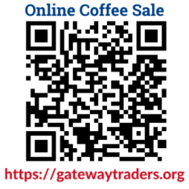
Thank you for your support,
(YOUR FULL NAME)
(PACK/TROOP w/ NUMBER)

