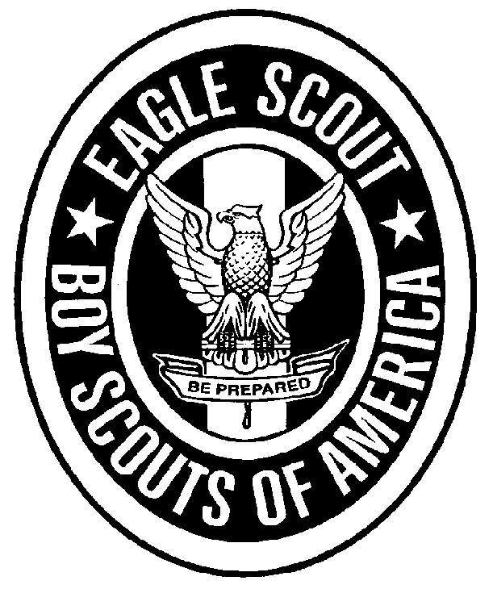
Dear Eagle Scout,

Congratulations on earning the Eagle rank! The district would like to issue a press release for your achievement in earning your Eagle rank. Please complete the below form and return to the council office with your approved Eagle application.
A photo in uniform with your Eagle medal (head and shoulders) or in uniform with your Eagle Project would be most helpful. You can also email this information to dave.chambliss@scouting.org.

Your name as you want it released ___________________________________________Age_______

Year in school ____________ School ________________________________________________

Parents’ Name _________________________________Date Received Eagle Rank_______________

City___________________________________________________Phone____________________

Scoutmaster/Exploring Advisor Name___________________________________________________

Troop Sponsor & Unit #______________________________________________________________

Eagle Scout Project Title: _____________________________________________________________

Eagle Scout Project Purpose: __________________________________________________________

____________________________________________________________________________________

Eagle Scout Project Description (who did the project benefit, how will the project be utilized by others, why did you choose this project, etc.:
____________________________________________________________________________________

____________________________________________________________________________________

____________________________________________________________________________________

____________________________________________________________________________________

Date Eagle Scout Project was started/completed: _________________________________________

Other Scouting Achievements/Awards: __________________________________________________

____________________________________________________________________________________

____________________________________________________________________________________

Other Extra Curricular Activities: _______________________________________________________

____________________________________________________________________________________

____________________________________________________________________________________

What publications would you like this sent to in your area? _________________________________

____________________________________________________________________________________

Things I personally gained from the Eagle Scout Project Experience (leadership skills, teamwork, vision of where I want to go etc.):

____________________________________________________________________________________

____________________________________________________________________________________

