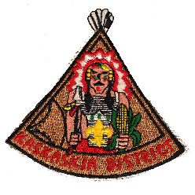SCOUTMASTER OF THE YEAR
KASKASKIA DISTRICT
REQUIREMENTS
The nominee shall have served (registered) as Scoutmaster for a minimum of 8 months during the year. The nominee shall have completed required training for the position.
OTHER FACTORS FOR CONSIDERATION
______ Attends Roundtables _______ Active in District and/or Council
______ Participated in a Long-Term camping experience ______ Years served as Scoutmaster
______ Troop achieved Gold / Silver / Bronze JTE Unit status (circle level) during year _____
All of the above requirements have been considered and I hereby nominate:
NAME (print) ______________________________________________ UNIT# ________
ADDRESS ____________________________________________________________________ CITY/TOWN __________________________________________ PHONE ________________ Basis of nomination (include examples and advance training participated and/or staffed)
Other noteworthy service in their community: (Example – PTA, Church, Rotary)
***********************
NOMINATOR _______________________________________ DATE ____________
PHONE _____________________ SCOUTING POSITION / UNIT________________/_____
2014 Revision If needed, use back of form or attach additional information
Greater St. Louis Area Council Boy Scouts of America

