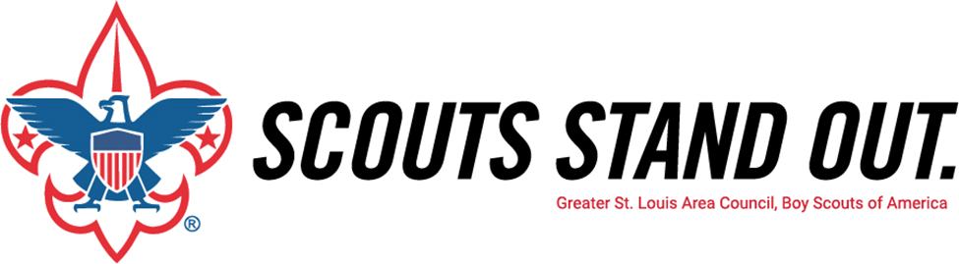
Greater St. Louis Area Council, Boy Scouts of America
{DATE – WITHIN TWO WEEKS AFTER PRESENTATION}

Dear {PARENTS FIRST NAME(S)},

I am pleased to announce that at our {BLUE&GOLD/COURTOFHONOR/PARENTMEETING}Court of Honor, we raised {AMOUNT RAISED} of our ${UNIT GOAL} goal for the Greater St. Louis Area Council Family Friends of Scouting Campaign. We feel good about our progress so far, but there is still more to be done.

We haven’t heard from you yet, so I wanted to let you know, once again, how important your support is for Scouting in our community. For more than 100 years, the Boy Scouts of America has been preparing our youth for the future. Scouting is more important to today’s youth and our communities more than ever. I am asking you to help our local Council continue to deliver the values of Scouting to our youth. We need your support this year more than ever to continue providing the highest level of quality program for our youth.

The annual Friends of Scouting campaign provides the direct support for our {PACK/TROOP/CREW/POST}Troop Troopand its leaders by providing:
• Camp properties for summer and weekend  camping and activities  • Activities and Programs for your Scouts  • Training and Courses for leaders  • Assistance to disadvantaged youth | • Program outreach  • Membership recruitment and Advancement  • Service Centers and Scout Shops  • Accident and General Liability Insurance

As a Scout parent, we see first-hand the benefits of Scouting and we hope you will consider giving a voluntary contribution to the campaign for 2021.

Every gift is important to the success of our Scouting programs. There are opportunities for everyone to support the Family Friends of Scouting at a level that can help us along, propel us forward, or even leave a legacy. There are many ways to give to the Family Friends of Scouting Campaign through a cash or check donation at the presentation, credit or debit card, or through a pledge that is paid on a monthly, quarterly, or semiannual basis.

Please take a moment to look over the information included in the enclosed brochure/pledge card, complete your pledge card, and return it to me at your earliest convenience. If we have not heard from you within a week, we will follow up with a phone call to you. We are anxious to turn our results in and are hoping we can count on you to help us achieve 100% participation in our {PACK/TROOP/CREW/POST}.

Once again, thank you for your consideration of this important request. If you have any questions, please call me. Together, we can help deliver the promise of the Scouting program.

Yours in Scouting,

{UNIT COORDINATOR NAME}
{PACK/TROOP/CREW/POST} {UNIT NUMBER} FOS Coordinator
P.S. – Remember your company may match your contribution. It is a great way for your employer to recognize your contribution and involvement within Scouting. More information about Matching Gifts and Friends of Scouting can be found at www.stlbsa.org/give.
LET’S MAKE THIS EASY by texting {REGIONAL KEYWORD} to 91999 TODAY
to make your contribution online via your credit or debit card.
Watch the campaign video here: https://youtu.be/z4takO90GvI

